Dhanopinion Information Centre as on 4 June, 2026

Contents
There is always some risk 3
Diversification reduces risk 6
Compounding can deliver exponential growth 8
Inflation, Real Value and the Money Illusion 10
Asset Allocation 13
Defining your investment horizon can lead to better planning 16
Equity – Risk and Return profile 17
Fixed Income – Risk and Return profile 21
Active and Passive Investment Management 23
Index Investing Strategy 27
Competitive Financial Markets and the implications for investment strategy 31
Keep the cost of investing low 34
Taxes and their impact on investment outcomes 37
When investing in a Mutual Fund, choose a Direct MF over a Regular MF 39
A liquid mutual fund is better for short-term needs than a bank savings account 42
National Pension System (NPS) 44
Bank Fixed Deposits 49
Government Bonds 52
Government Savings Schemes 56
Senior Citizen Saving Scheme (SCSS) 58
Public Provident Fund 60
Equity Linked Saving Scheme (ELSS) 62

There is always some risk
August 31, 2025
Preservation and growth of money, simple as they may sound, are not easy tasks. In the olden days one may have needed to protect money from thieves and robbers. The modern world has its share of thieves and robbers, though most of them will not rid you of your valuables at gunpoint.
Investing is a choice being made by the investor. A choice needs to be made because the future is uncertain. Though we have some idea about how it might turn out, nobody knows for sure. Just because a certain commodity has appreciated over the last 5 years does not mean it will do so for the next 5 years as well. Investment advertisements regularly and mandatorily warn investors that past performance is no guarantee of future returns.
Most investment advisors will have you fill out a form based on which they evaluate your ‘risk profile,’ or ability to take investment risks, and recommend options accordingly.
The risk-reward trade-off is well known. The greater the projected return, the greater the risk. Investors with a low ability to handle risk are recommended safe options like government bonds and bank deposits.
What you are not told is that there is risk in every investment.

Equity Investing
Equity is designed to bear risk in bad times.
When you invest in equity you take the risk that the business will be unsuccessful and that you will lose money. The only reason that people invest in equity is because they expect that on average the business will be successful and that they will make money as compensation for bearing this risk. Historically equity markets have delivered high returns. It is reasonable to expect that in the future too, one should expect to get higher returns for bearing equity risk. However, when one invests in equity, one is taking risk while hoping to generate higher returns than fixed income investments like government or corporate bonds or bank fixed deposits.

Fixed Income Investing
With fixed income instruments, there is a promise to pay you for borrowing money from you. These come with an interest rate and a schedule for payment of principal. The interest rate can be fixed or floating based upon a specified index.
Fixed income investments have credit risk – that the promises of fixed payments made are not kept. There can be a default; the promising entity may go bankrupt. If the counterpart to a fixed income investment is very good, such as the government in its own currency, the credit risk can be very small.
The value of traded fixed-income investments changes as interest rates change and they can go up or down in value as interest rates decrease or increase.
Fixed Income investments are denominated in terms of money and the value of money has fluctuated over time, with a general tendency to decline in value as a result of inflation. The real (inflation adjusted) value of fixed income instruments is therefore exposed to risk. Over time, the decline in real value can be substantial.
There are inflation-linked instruments, which promise a fixed real or inflation-adjusted return. If the promise comes from a government the credit risk can be minimal. However, there exists the risk that the calculation agent (often a government related entity) does not properly reflect actual inflation as has happened in Argentina. There are controversies about the calculation of inflation in other countries. Even eliminating that risk, taxes are due on nominal returns. Therefore, even if one has a fixed real rate instrument from a government, the after-tax real value will not be fixed and therefore have risk.
When economies go through crisis and turmoil, all assets can do very poorly with many assets losing almost all value; Zimbabwe, Venezuela and Lebanon are examples. Recently, Sri Lanka and Pakistan are examples closer to home where there was no place to hide without bearing significant losses in domestic assets. This makes the case for investing abroad, if possible, worth considering. However, changes in the law and taxation can reduce the returns from foreign assets as well in times of crisis.
While real estate and human capital are not included in the investments we are considering, it is worth highlighting some aspects of the value of investing in real estate and human capital.

Real estate
Real estate has the benefit of going up in value with inflation as well as growth in population and per capita income. Residential housing is the largest expenditure for families. Owning residential real estate hedges one’s future expenditure or liability stream on account of rental payment and therefore reduces the risk of affordability of housing. It therefore has attractive risk-return characteristics over long horizons, particularly when one considers simultaneously one’s assets and liabilities. However, as refugees have experienced, when one is uprooted, one cannot take real estate with you.

Human capital
Investing in human capital, particularly for one’s children, has the benefit of always being with them through crisis and turmoil. It is also a real asset and exposed to growth in the economy through growth in population and per capita income. Human capital also has positive lifetime externalities.

Conclusion
So, what should one do if one wants a low level of risk?
Short term government bonds are often described as a risk-free asset. This is pretty accurate if one has a need for the funds over a short horizon. The rate is fixed; there is no exposure to changes in interest rates and the inflation rate over a short horizon can be pretty accurately predicted based upon recent history. The risk in both nominal and real terms is almost nil. However, most people seldom have a very short-term horizon for their investments. For those with a long-term horizon, short-term government bonds can be quite risky in nominal and even more so in real terms, particularly in emerging markets with high and variable levels of inflation. For those with a long investment horizon, typically real outcomes are more important than nominal outcomes. An inflation-linked government bond investment with a maturity matching the investment horizon could be considered low risk to the horizon. The value of this investment will however vary on a daily basis.
The investment horizon matters when one considers risk.
Equity is a real asset in that revenue and profit can be expected to go up with inflation. One can make the case that over long horizons fixed income investments are not as much lower in risk than equities than they are over shorter horizons. In emerging markets with higher and more variable inflation, the difference between fixed income and equity risk can be lower than is the case with developed markets with lower and more stable inflation rates.
Equities have historically delivered higher returns over long horizons.
If someone tells you that equity always pays off in the long run, have them take a look at the equity markets that ceased to exist after communist transitions in Russia and China and the equity market experience in Japan.
Bank deposits carry the risk of bank failure. Deposits in banks are insured only up to ₹ 500,000.
There could be liquidity risk; the inability to cash out when you need the money.
While a government might ensure that instruments like bank deposits and government bonds are honoured, they cannot guarantee the non-depreciation of the currency in case of economic mismanagement.

Diversification reduces risk
November 29, 2025
The basic rule in managing a portfolio is to follow the classic advice “Do not put all your eggs in one basket.” Things can go wrong and you do not want to get badly hurt with any particular future outcome. Generally, diversification is one of the few free lunches in investing. By diversifying, you reduce risk and do not reduce expected return.
Recognizing that the future is uncertain, investors need to take investment decisions that take into account the fact that their investments may not turn out the way they thought it would at the time of making the investment. This is applicable even to investors who have an appetite for bearing high levels of risk. You don’t want freak accidents and events wiping out your future.
You believe you have identified the perfect stock to invest in. You expect it to deliver handsome returns over a long period of time.
You have a choice. You could invest all your available money into it, or you could invest a part and the remaining in some other stock.
By investing all in that one stock you are giving yourself the best chance of a good return. However, you are also exposing yourself to a high level of risk as it is an individual stock exposed to events, circumstances, cycles and other vagaries. By not investing the entire amount in this single stock, you are probably going to earn lower returns, but you are protecting yourself against the risk of a total wipeout in the event of a freak incident derailing that one investment.
Diversification can be done at many levels.
You could invest in the stock of another company in the same industry.
You could invest in the stock of a company in a different industry, giving you additional protection against a freak incident impacting the original industry.
You could invest the remaining amount in a mutual fund, gaining greater protection with exposure to a basket and not individual stocks.
You could invest the balance in fixed income securities such as bonds, gaining further protection against the vagaries of a single market, the stock market.
And so on.
The risk of investing in risk-prone products such as individual stocks can be substantially reduced by investing in a diversified portfolio of individual stocks.
If diversification is so important, why do we prefer a single index fund for equity rather than diversifying among a number of funds?
We suggest that your asset allocation strategy looks to determine the amount of equity risk that is a good match for you and then use the funds to get exposure to the desired level of equity risk.
A good broad index fund gets you exposure to a diversified basket of stocks. In comparison, while a number of equity funds will give you more diversity than a single fund, they all have exposure to a list of stocks. If you calculate the list of stocks that you have through the many funds, you will come up with a list which is diversified but probably not much more diversified than a single index fund.
There is often a lot of overlap among different funds and the underlying exposures may get to a similar level of diversity than a single index fund. Our favourite equity index fund where possible is the one that invests in the global stock market and invests in every public company in proportion to the amount of free float market value of the equity outstanding. It is hard to get more diversified equity exposure than this single index fund, no matter how many equity funds you buy. As you buy more funds, the diversification will ensure that your returns before fees get closer to the market. The overall diversification will be worse or equal to the index fund. The costs of active funds are much higher than index funds and in the long run, your after-tax returns are likely to be lower unless the mutual funds outperform as a group. If you are actually picking active funds, it is better to stick to a small list rather than a large number of funds.
There are many articles and resources that talk about diversification. You can learn more about diversification here: https://www.investopedia.com/investing/importance-diversification/

Compounding can deliver exponential growth
March 25, 2026

Compound interest is an exponential growth phenomenon
We are generally used to thinking in linear terms and not very good at understanding the accumulated effect of small differences in growth rates over long periods of time. The tables below give us the impact of different rates of return over different time horizons, and the difference between simple and compound interest.

Simple interest effect over different periods of time
Years  Interest rate | 1 | 2 | 3 | 5 | 10 | 25 | 50 | 100
1% | 1.01 | 1.02 | 1.03 | 1.05 | 1.10 | 1.25 | 1.50 | 2.00
5% | 1.05 | 1.10 | 1.15 | 1.25 | 1.50 | 2.25 | 3.50 | 6.00
10% | 1.10 | 1.20 | 1.30 | 1.50 | 2.00 | 3.50 | 6.00 | 11.00
25% | 1.25 | 1.50 | 1.75 | 2.25 | 3.50 | 7.25 | 13.50 | 26.00
At a return of 1% simple interest p.a., an amount becomes 1.5 times the initial amount in 50 years and twice the original amount in 100 years.
At a 5% simple interest return, an amount becomes 3.5 times the initial amount in 50 years and six times the original amount in 100 years.

Compound interest effect over different periods of time
Years  Interest rate | 1 | 2 | 3 | 5 | 10 | 25 | 50 | 100
1% | 1.01 | 1.02 | 1.03 | 1.05 | 1.10 | 1.28 | 1.64 | 2.70
5% | 1.05 | 1.10 | 1.16 | 1.28 | 1.63 | 3.39 | 11.5 | 131.5
10% | 1.10 | 1.21 | 1.33 | 1.61 | 2.59 | 10.83 | 117 | 13,781
25% | 1.25 | 1.56 | 1.95 | 3.05 | 9.31 | 264.70 | 70,065 | 4,90,90,93,465
At a return of 1% compound interest p.a., an amount becomes 1.64 times the initial amount in 50 years and 2.7 times the original amount in 100 years.
At a 5% compound interest return, an amount becomes 11.5 times the initial amount in 50 years and 131.5 times the original amount in 100 years.
What do we see?
Money invested on compounding terms amounts to a whole lot more than the money invested on simple interest.
Why does this happen when the rate is the same?
The primary reason is that simple interest, once earned, does not get reinvested. It is probably drawn out for expenditure. When invested on compounding basis, the earnings get ploughed back into the investment and generate returns in addition to the returns generated by the principal. In a few years, the interest starts becoming bigger than the principal and generating a whole lot more money.
There are two variables on which this works:
– The duration; the longer the investment period the greater the benefit
– The rate of return; the higher the rate the greater the benefit
In our example, at the rate of 1% per annum, the amount is almost the same after 10 years,
a little higher at the end of 100 years.
When invested at 10% p.a., the difference starts becoming visible earlier. After 5 years, ₹ 1 amounts to ₹ 1.50 using simple interest and ₹ 1.61 using compound interest. From
here onwards, compound interest keeps pulling away. After 50 years, simple interest yields
₹ 6 while compound interest yields ₹ 11.74.
As the rate and amount increase, the difference expands.

Recommendation
Start investing early and give your money a chance to grow. Allow the earnings, as they
accrue, to generate returns as well.

Inflation, Real Value and the Money Illusion
March 26, 2026
We are accustomed to using money as a stable store of value over short horizons. We have a tendency of evaluating portfolio outcomes and risk in nominal terms rather than in real terms which is what really matters over long horizons.
What do we mean by “nominal terms?” What is “real terms?”
Let us take an example.
You have an investment that delivers a return of 7% per year. The ₹ 1,000 you invested at 7% on 1st January 2021 gave you an additional ₹ 70 on 1st January 2022. You spend the ₹ 70 and invest the ₹ 1,000 once again at 7% on 1st January 2022 which gives you an additional ₹ 70 on 1st January 2023 leaving the ₹ 1,000 intact. If the return remains unchanged you will get an another ₹ 70 on 1st January, 2024. And so on.
The price of a masala dosa at your favourite Udupi restaurant on 1st January, 2022 is ₹ 70. You received the ₹ 70- return from your investment and spent it on the dosa on 1st January, 2022.
You want to eat a masala dosa at your favourite Udupi restaurant once again on 1st January,2023 when you receive the ₹ 70 return from the investment. You walk in with a swagger and order your favourite dosa and devour it hungrily. When you ask for the bill, you get a shock when you realize you have to pay ₹ 77. You protest and speak to the owner who expresses his inability to reduce the price as the cost of input materials like flour and potatoes has gone up. You end up paying ₹ 77. Not only have you paid the earned interest but also an additional ₹ 7 leaving you with lesser to invest for the future.
This is the impact of inflation and its relationship with investing.
On 1st January, 2023, you have received ₹ 70 in “nominal terms.”
However, in “real terms” it is worth less than it was worth on 1st January, 2022.
Why?
Because today’s ₹ 70 is not able to buy you the same amount of goods and services that it was able to buy you one year back.
The price of the dosa increasing from ₹ 70 to ₹ 77 is known as inflation.
Inflation can be defined as an increase in prices from one period to another. On the flip side, it could be described as the rate at which the value of money erodes or depreciates or loses its power to purchase. In the context of investment, it is the rate at which one needs to earn from investments to keep the standard of living at the same level. If inflation in 10% and your “nominal” investment return is 7%, your “real” or effective investment return is minus 3%.
In economic terms, increase in the supply of money relative to the productive output leads to more money chasing fewer goods which results in inflation.
Inflation, though it seems opposed to the well-being of individuals, is supported by policy makers as it is believed to promote a stable, sustainable and predictable economic environment. However, at low/ moderate levels. When it goes beyond these levels, it can have deleterious economic outcomes.
If the price of everything were to rise at exactly the same rate, then it would not matter and nothing would change. People would not become richer or poorer as a result of inflation. However, not everything is impacted equally.
Among asset classes, the liquid asset classes tend to appreciate at a slower pace as compared to the less liquid asset classes. Hence, a move away from holding liquid assets is recommended as a strategy to counter the impact of inflation over a long-term.
What should individuals strive for?
- That their investments yield a return which is higher than the rate of inflation.
- That their earnings increase annually at least as much as the rate of inflation.
The International Monetary Fund (IMF) reports India’s inflation since 1960 as follows:
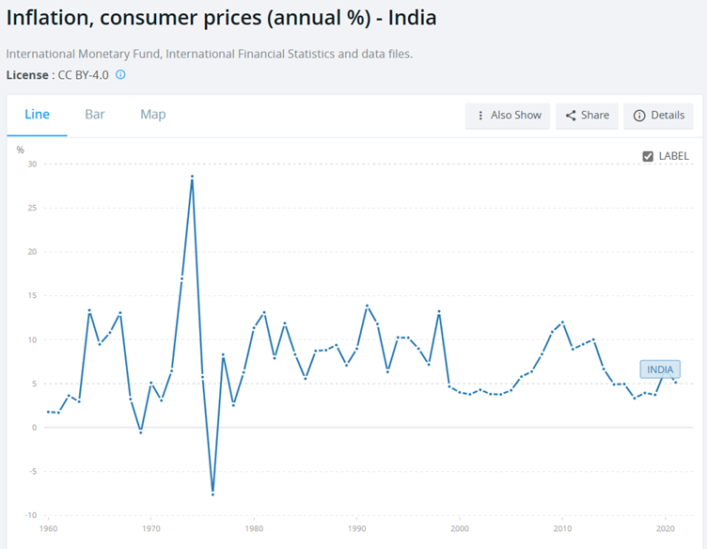
Source: World Bank
We can see that inflation based on consumer prices has hovered at around 5% annually over the last quarter of a century, with a spike towards the end of the first decade. Inflation in the last century has been much higher.
What this means is that the value of what a Rupee could buy has become smaller over time.
How much smaller?
IMF tells us how much in the chart below:
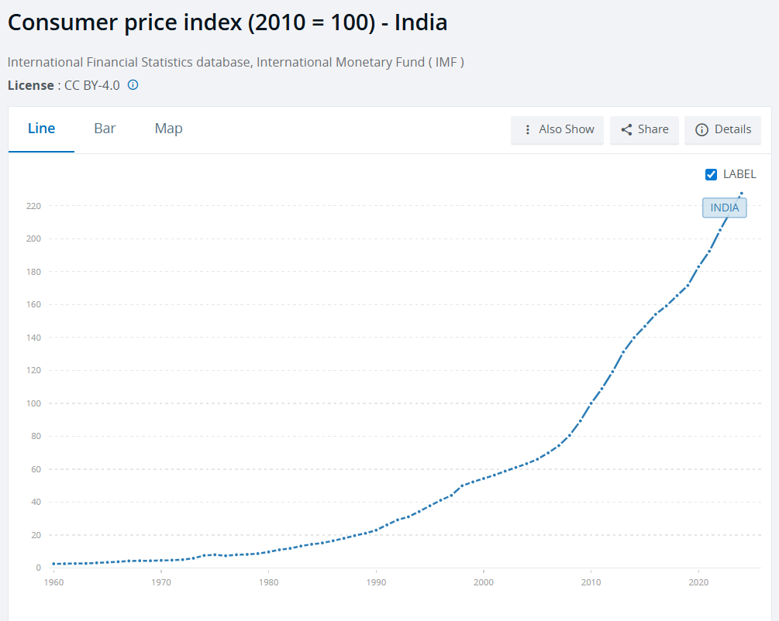
Source: World Bank
An item that cost ₹2.50 in 1960 cost ₹100 in 2010 and ₹220 in ₹227 in 2024.
According to another calculator provided by World Data , if you could buy a certain basket of goods and services for ₹ 1,000 in 1961, in 2022, 61 years later, you need ₹ 78,071 to buy it.
Another way of looking at the decline in the value of Rupee over time is its value against the US dollar, as shown in the chart below, produced by XE.com.
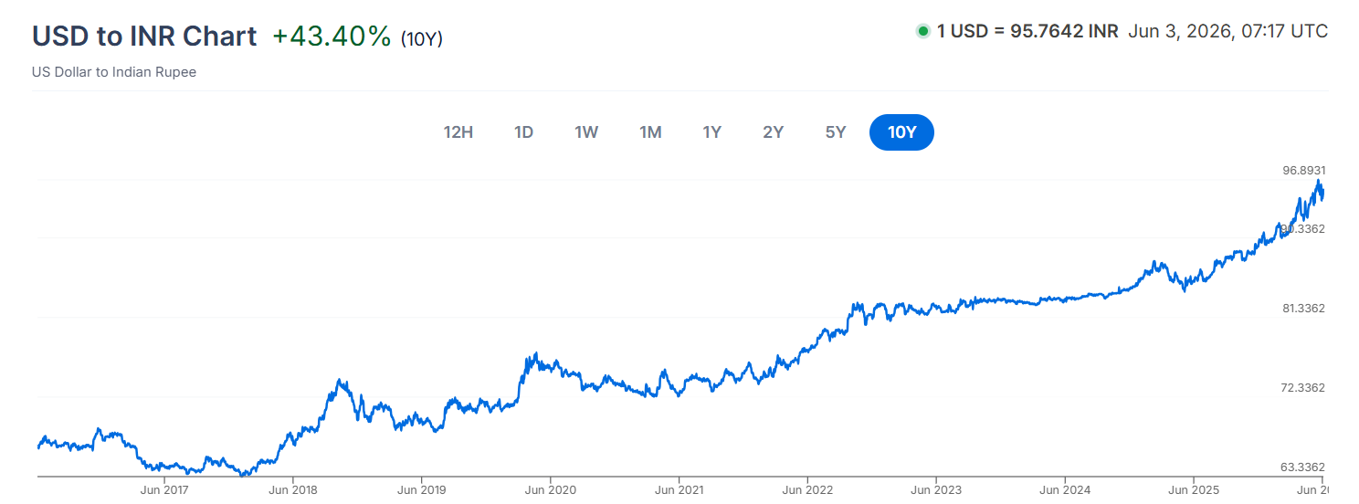
Source: XE.com
In June 2016, one could buy one dollar with ₹67. In June 2026, one needs more than ₹96 to buy the same one dollar.

Asset Allocation
March 27, 2026
Despite the very large number of securities available to investors, it turns out that investment results are dominated by asset allocation more than individual security selection – because individual security impact gets reduced through portfolio effect of diversification.
Getting the asset allocation to match one’s objectives and risk preferences becomes a very important part of the investment process.

What is asset allocation?
Asset allocation is the process of determining the level of exposure you wish to have to various asset classes. At the highest level, it is a division between exposure to equity and exposure to debt or fixed income investments. This is the level at which we will refer to asset allocation in our articles and recommendations. Of course, one could choose to drill down further and sub-divide each into various sub-classes. One could also bring alternative asset classes into the purview of asset allocation.
The purpose is to ensure that investments are made in an informed manner that lead to meeting your investment goals, and not in a haphazard manner. It enables you to avoid the pitfalls of some asset classes dominating your portfolio and creating concentration risks, as well as investing in a manner that does not lead to your goals.
It is generally recommended that you could choose a higher exposure to equity at a young age. It gives you the opportunity of earning higher returns over a long period, and giving you the opportunity of recovering from setbacks in a more volatile equity market as compared to debt. With advancing age, it is recommended to lower the equity exposure and increasing that of debt.
Asset Allocation is primarily a function of age of client and spouse. Recommended Asset Allocation and Existing Asset Allocation results in recommended asset allocation shifts. After asset allocation is determined, pick from ranked investment list till available amounts are filled within each asset category.

What is the right asset allocation for you?
Not easy to answer but there are reasonable starting points.
One way of doing it is to start with the assumption of 100 being your target age, with exposure to equity being 100 – present age. If you are 30, your equity exposure could be 70% of your portfolio. By 70, it should have reduced to 30%.
This should be adjusted based on personal situation and preferences. The table below depicts recommended allocation levels based on variables such as age, professional stability and income and assets:
Variable | Higher | Lower
 | Equity exposure
Age | L | H
Job/ professional stability | H | L
Income and assets | H | L
Responsibilities/ dependents | L | H
Ability to handle risk and uncertainty | H | L

A sample allocation model based on risk-taking ability:
Risk Level | Equity | Debt
Aggressive | 90% | 10%
Moderate | 60% | 40%
Conservative | 30% | 70%

What some well-known investment management firms say
But this is just one view.
Everyone has a view on asset allocation, and most follow the principle of starting with a high allocation to equity and gradually bringing it down as you age.
You should also look at the allocation recommendations of some of the most established names in investing and retirement planning.
Here are links to some of their recommendations with regard to asset allocation:
Vanguard
Blackrock
JP Morgan
Morning Star
These are all good places to start. One can check out their model portfolios, look at the simple 100- age heuristic and see what may be the best fit given one's circumstances.
It is good to think about how one is different from the average and why these providers recommend what they do. This can help you arrive at the best match for one's circumstances and preferences.

Target date fund
A simple solution that could be suitable for many investors is to pick a low-cost target date fund (TDF) that corresponds to one’s retirement horizon.
It is a type of mutual fund or retirement fund that seeks to optimize returns with a defined target (future) date in mind which (target date) is also included in its name. To achieve this objective, it automatically adjusts its asset allocation based on its target date, typically moving from high-risk equities in its earlier years towards lower-risk debt as the target date approached.
As an investor, you can choose a fund that is closest to your target or retirement date, and one that has an investment strategy that is aligned with your goals. Thereafter, you will not need to keep rebalancing by shifting from equity to debt as you age, the fund will do it for you.
This is one of the under-appreciated benefits of modern financial solutions. A simple, easy to understand low-cost solution that will beat most solutions offered and currently used.

Conclusion
No matter how one looks to manage a portfolio, seeing and managing one’s asset allocation is an important decision with long-term impact.

Defining your investment horizon can lead to better planning
March 29, 2026
When are you investing for?
Putting away money for the future is a smart thing to do, but not having it available when you need it, is not.
In America, the concept of retirement and saving for retirement gained traction in the 1930s with the introduction of social security. While there is no single retirement age, 65, when social security payments could be encashed, has been considered as that number.
in 1900, the 65+ group had only 3 million members, reflecting a nation with a young population, a mere 4 percent in a population size of 76 million.
Life expectancy crossed 65 in 1944. Therefore, till 1944, the probability of the retired adult enjoying the fruits of his savings was low, since the average person did not live beyond 65.
It crossed 70 in 1964. Even in 1964, only 5 years of post-retirement expenses were needed by most people. Creating a fund over 40 years of working life for a retirement period of 5 years did not create too many cases of distress.
However, with rising life expectancy, it is close to 80 now, the requirement has kept increasing, along with which has gone up the need to save a larger part of earnings during working years.
The same is the situation in India, with rising life expectancy. It is important to be able to project your likely lifespan in order that finances can be handled better. While it is not an exact science, the Actuaries Longevity Illustrator (“ALI”) helps you get an idea.
You can access it here: https://www.longevityillustrator.org/
While life expectancy tables will tell you how long an individual of your age, gender, and health would be anticipated, on average, to live. And therein lies the catch. What you need to plan for is not how long the average person will live but how long YOU will live.
If you plan for the average and live less than it, you may be adequately funded for old age but may need to live a more penurious life when young than needed. On the other hand, if you plan for the average and live longer, you may run out of money in old age. It is a very personal choice but being aware of the consequences, hopefully, leads to more informed decision-making. There are other considerations as well. For instance, the funding provided may be to cover the old age of two people. In that case, the longevity assessment becomes even more complex.

Equity – Risk and Return profile
March 30, 2025

The nature of equity investing
Equity is designed to bear risk in bad times.
When you invest in equity you take the risk that the business will be unsuccessful and that you will lose money. The only reason that people invest in equity is because they expect on average that the business will be successful and that they will make money in compensation for bearing this risk. Historically equity markets have delivered high returns. It is reasonable to expect that in the future too one could expect to get higher returns for bearing equity risk.
Equity markets returns have been very attractive historically, particularly over long horizons. However, the trade-off is that one is exposed to significant risk of losses. When one invests in equity, one is taking risk while hoping to generate higher returns than fixed income investments and interest rate investments like government or corporate bonds or bank fixed deposits.

Understanding equity drawdown
A drawdown, or equity drawdown, is a key measure to understand the maximum loss an investor could have made during a past period.

Calculating a drawdown’s magnitude
It is expressed as a percentage of the peak against which it is measured.
Drawdown = Peak Value – Trough Value
Drawdown % = (Peak Value – Trough Value) / Peak Value %
As can be gleaned from the formula, it is a lag measure and can be calculated only in hindsight. Also, it can be calculated at any point against a prior peak. However, if the market is continuing to decline, the current calculation may not reveal the full magnitude of the drawdown.
As opposed to a loss, the calculation of which is triggered by a sale event, drawdown is an ongoing, intrinsic part of equity movements. In a volatile, independent marketplace, it is inherently fallacious to believe that equity values will only go up. In fact, it is believed that US equities have spent nearly 90% of their time below a prior peak.

Recovery from a drawdown
Another critical aspect of drawdowns is the nonlinear relationship between the downward slope to the trough and, thereafter, the climb back up the hill.
The percentage gain needed to return to the break-even point (prior peak) is always greater than the percentage of the drawdown. To illustrate:
- A 10% drawdown requires an 11.1% gain to recover.
- A 20% drawdown requires a 25% gain to recover.
- A 50% drawdown requires a 100% gain to recover.
- A 70% drawdown requires a 233% gain to recover.

Historical performance
The US markets have the longest and best statistics available and are also the largest equity markets, estimated to account for 60% of global capitalization weighted indices. They are a good place to start to get a sense of historical returns for equity. Investing is about making choices and so one should look at the returns on equity and other assets as well to make an informed choice.
History can provide some context. Table 1 shows the historical performance of US stocks and bonds over a 100-year period as tracked by Northern Trust. In other words, it shows the types of losses one should be prepared to withstand when one invests in equity.
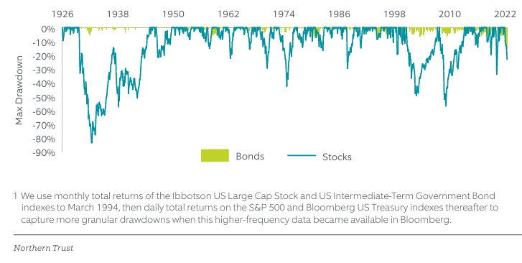
Source: Northern Trust
Extracts from the same data, differently presented, capture the maximum drawdown, the lowest point reached since the previous peak, across different drawdown events in history. The Great Depression is clearly the sharpest, will a fall in value of over 80%.
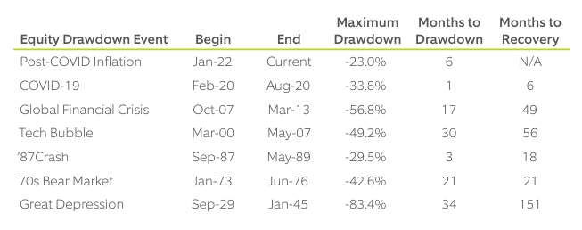
Source: Northern Trust
The Great Depression took 151 months to recover, nearly 13 years, even though the drawdown had taken only 34 months.
In an article published in December 2024, StatOasis commented on drawdowns in other global markets and said, “Market volatility isn’t unique to the U.S. In the UK, the stock index faced a devastating 73% drawdown in 1972, taking nine years to recover. Even worse, the crash in 2000 required a gruelling 20 years to finally post new highs in 2024.”
Japan’s Nikkei index presents another sobering example. After a massive speculative bubble burst in 1990, the index posted annualized returns of -4.78% for over 20 years. It still hasn’t recovered to its peak levels today.”
Indian equity is not immune to drawdowns either. A LinkedIn post by Sonali Das states that between January and October 2008, the Nifty 50 witnessed a drawdown of over 60%. Though the race to the bottom took less than a year, the recovery took over 5 years.

The challenge for investors
Herein lies one of the great challenges of stock investing. Though values did eventually recover, they took many years. If an investor needed to cash out during this period, he/ she would have had to invariably book losses. This is also one of the reasons why investors are advised to reduce their equity exposure as they age. At a young age one has time to recover from drawdowns. But, at an advanced age, one may not.
In an article published on July 17, 2025, MorningStar suggests, “Market crashes always feel scary when they happen, but there’s no way to know in the moment whether you’re encountering a minor correction or looking down the barrel of the next Great Depression. But since the path to recovery is so uncertain, the best way to be prepared is by owning a well-diversified portfolio that fits your time horizon and risk tolerance. Investors who stay invested in the market in the long run will reap rewards that make the turmoil worthwhile.”
Looking through historical data, one can get some sense of possible losses. When investing in a well-diversified portfolio of equities, one should be prepared that one has a loss of 30 to 50%. One cannot rule out the possibility of losses of 80% or even more.

Recommendations for prudent investors
The good thing is that, historically, values have recovered over time. Even if you were looking down the barrel of the next Great Depression, history shows us that there was a light at the end of the tunnel.
With the ultimate goal of building a portfolio that withstands extreme market stress and grows during favourable conditions, the prudent investor focuses on resilience and planning and avoids predicting and avoiding drawdowns.
Know thyself – Identify one’s ability to withstand extreme conditions without capitulating. An honest evaluation itself will drive equity allocation strategies.
Allocation – This remains the bedrock of long-term investing. Allocation can be done at multiple levels. Within equity, one could allocate judiciously between industry sector, high/mid/low cap, based on investment styles, etc.
Rebalancing discipline – As values go up and down, it becomes important to rebalance. Instead of impulsive rebalancing, a rules-based approach, whether based on a calendar, or thresholds of value, is recommended.
Monitor – The investor cannot make investing a one-time activity. The portfolio needs to be monitored, along with keeping an eye on the broader market with the help of information provided by analysts. Over time, an investor should develop a set of indicators and tools to be monitored on a regular basis.

Conclusion
Does this mean that equities do not have much risk if one is prepared to hold for long periods of time and follow a prudent approach? The answer is no. Just because the markets came back historically, does not mean that they will recover fully from large losses in the future. Owners of equity are taking a risk and should be prepared for a permanent loss and the loss could be significant. However, given the historical experience – selling after a large loss may not be well advised. If one does take equity risk, it is worthwhile to plan to ride through large losses rather than sell when the pain is highest.
Uncertainty lies at the heart of all future events. An investor’s focus should be on planning and discipline, and not prediction and one-offs. By doing so, an investor can hope to benefit from the long-term wealth-creation opportunities that equities have historically offered.

Fixed Income – Risk and Return profile
March 31, 2026
Fixed income investments refer to investments which promise upfront the returns of interest and principal. For very strong entities, like the Government, there is little risk of default on these promises to pay. Therefore, on a horizon matching the maturity of these investments, one knows exactly what one will get and there is no risk of returns different from those promised. For a short-term government obligation, there is no risk of loss in the nominal value of the investment and therefore these investments are often referred to as risk-free investments. For longer maturity fixed income investments, the value will fluctuate on a day-to-day basis as interest rates fluctuate. As interest rates go up the value of the investments will go down and as the interest rates go down, the value of the investments goes up. The longer the maturity of the investments, the more the fluctuation in value. However, unlike equity investments, while the value fluctuates on a day-to-day basis, the maturity value is fixed, and the value will converge to the maturity value.
Does this mean that fixed income is without risk?
No. There is no risk if one is interested in nominal returns with a horizon equal to the maturity of the investment. However, over a horizon different from that of the maturity of the investment there will be fluctuations in value and therefore risk. However, this risk is much lower than for equity investments.
The second factor that creates risk for fixed income investments is that most people are concerned over long horizons with the real value of their investments. Since inflation over time is both significant and potentially volatile, investments in fixed income do not eliminate risk in real terms. While there are options to invest in real or inflation linked fixed income investments and these can eliminate inflation risk over a term equal to that of the fixed income investment, for taxable investors even these do not eliminate inflation risk completely because income taxes will be due on nominal returns and high inflation will result in negative after-tax real returns even after investing in inflation linked fixed income investments.
Often when economies are doing well, equity markets go up and interest rates go up and the prices of fixed income investments go down. Conversely when economies do badly, interest rates go down and the value of fixed income investments go up. Adding fixed income investments therefore diversifies an equity-only portfolio. Fixed income investments are also less risky than equity investments, particularly in nominal terms and generally also in inflation adjusted terms.
Unexpected increases in inflation generally have a negative impact on the value of both equity and fixed income investments. There can therefore be situations where fixed income investments fail to diversify an equity portfolio.
Short-term fixed income investments for someone with a short horizon have no risk in nominal terms. For those with a longer horizon, there is no risk in nominal terms to the horizon but there is risk in nominal terms to different horizons than the maturity of the instruments. The risk of fixed income is typically much lower than for equity, particularly over short and medium-term horizons. However, in cases of unexpected hyperinflation such as was experienced in Germany, Hungary and Zimbabwe and more recently in Venezuela and Argentina, over longer periods, the value of fixed income investments can be totally decimated in real terms being more exposed to risk than even equity, because equity has a better chance of compensating for hyperinflation over longer horizons through the ability to adjust prices and revenues to inflation. In India over long periods of time, inflation has substantially degraded the real value of fixed income investments.
This is the reason why we believe that there is no asset without risk in real terms.

Active and Passive Investment Management
April 1, 2026

Passive Investing
A passive investment strategy is based on the belief that the market is efficient and it is difficult to outperform consistently through active management.
Instead of trying to beat the market, passive managers try to match the performance of an index by holding all (or a representative sample) of the securities in the index. The most common form of passive investment is through index funds or exchange-traded funds (ETFs).
Passive investing generally involves lower costs because of fewer transactions and lower management fees. It’s a long-term strategy and doesn’t aim to profit from short-term market fluctuations.

Active Investing
Active investing involves a hands-on approach and requires a portfolio manager or a team of managers to make decisions about how to invest a fund’s money. The goal of active management is to beat the market average, such as the S&P 500 index, or Nifty 50, and provide investors with a higher return.
Active managers try to do this thorough research and analysis, making forecasts, and using their own judgment to make decisions about what securities to buy, sell, and hold. They may also look to adjust the portfolio in response to market changes or economic trends. This strategy often involves higher transaction costs due to frequent trading and also higher management fees for the expertise provided.

Comparison of Active and Passive Investment Strategies
Active Investing is a Zero-Sum game and on average active strategies will underperform the market.
Passive strategies will give you market returns. In aggregate, the market will give you market returns. Since the Market Returns = Average Active Returns + Average Passive Returns, it follows that on average, Active Returns also equal market returns less the costs incurred. Therefore, if some active strategies outperform, there must be some other active strategies that underperform.
Most Active Strategies have historically failed to keep up with their benchmark indices. This is true in the US, India, and other parts of the world.

SPIVA Scorecards
S&P Dow Jones Indices is one of the largest providers of investment indices. They have been doing a comparison of the performance of active versus index or passive strategies for the past twenty years called the S&P Indices versus Active (SPIVA) scorecards, which are “semi-annual reports published by S&P Dow Jones Indices that compare the performance of active equity and fixed income mutual funds against their benchmarks over different time horizons.”

Key takeaways as articulated in Talking Points, a publication of S&P Dow Jones Indices:
- Most active managers underperform most of the time.
- The tendency for underperformance typically rises as the observation period lengthens. In the US, 79% of active managers underperform against the S&P500 over one year. This goes up to 89% over 5 years and 90% over 15 years.
- These conclusions are robust across geographies. The infographic below demonstrates the consistent and significant underperformance across markets over 5 years.
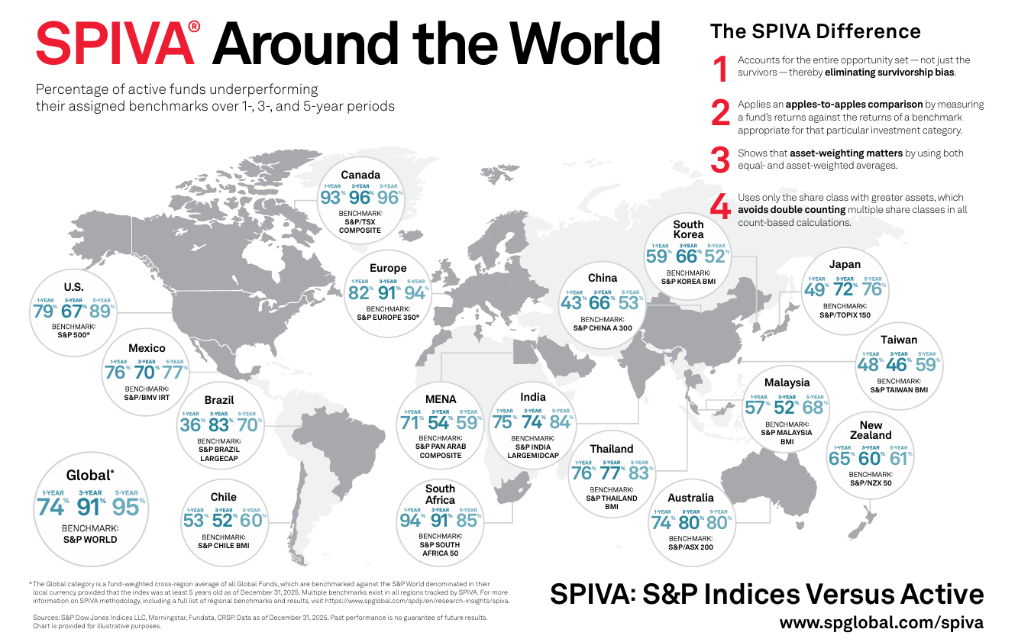
Source: SPGlobal
When good performance does occur, it tends not to persist, indicating the presence of “luck” in such outperformance. Above-average past performance does not predict above-average future performance. According to their persistence scorecard for the US which includes data for 2024, “persistence of outperformance was fleeting, with a small fraction of actively managed equity funds able to maintain consistent outperformance relative to their peers over the three- or five-year periods ending in December 2024.” Key findings:
- None of the top-quartile large-cap funds from 2022 maintained their position in the top quartile for the subsequent two years.
- Only 9% of the above-median large-cap active equity funds in calendar year 2022 remained above median in each of the two succeeding years. If outperformance were entirely random, we would expect a repeat rate of approximately 25%.
- Alpha persistence was fleeting, with a cross-category average of only 8.3% of active equity funds that surpassed the benchmark in 2022 able to consistently outperform their respective benchmarks over the subsequent two-year period.

SPIVA trends in India equities
The SPIVA India Scorecard measures the performance of Indian actively managed funds against their respective benchmarks over various time horizons. Highlights for year-end 2025:
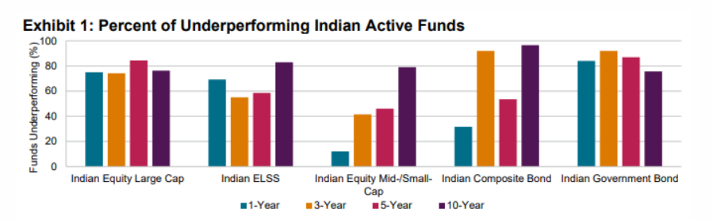
Source: SPGlobal
Indian Equity Large-Cap Funds – The underperformance rate hit 75.0% over the 1-year period, compared to 74.2%, 84.4% and 76.3% over the 3-, 5- and 10-year horizons, respectively.
Indian ELSS Funds – Underperformance rates were 55.0%, 58.5% and 82.9% over the 3-, 5- and 10-year horizons, respectively.
Indian Equity Mid-/Small-Cap Funds – The underperformance rate was just 12.1% over the 1-year period and reached 41.5%, 46.0% and 79.0% over the 3-, 5- and 10-year horizons, respectively.

SEBI Analysis
A SEBI initiated study of Profit and Loss of Individual Traders dealing in Equity F&O Segment done by the Department of Economic and Policy Analysis to analyse the trading by individual investors between FY 2019 and FY 2022 threw up sobering data as well. The study found that “89% of the individual traders (i.e. 9 out of 10 individual traders) in equity F&O segment incurred losses with an average loss of ₹ 1.1 lakh during FY22, whereas, 90% of the active traders incurred average losses of ₹ 1.25 lakh during the same period.”

Other considerations
Q. If more people employ passive strategies, will it not become easier for active managers to outperform since passive strategies just follow simple rules to track the market and do not concern themselves with issues such as valuation and investment flows?
A. If the passive strategies truly reflect the market properly, then no. This is because properly constructed passive strategies will reflect market performance. The smaller active share will remain a zero-sum game and every active winner needs to find an active loser.
There are some inefficiencies in the way indices track the market, particularly around rebalancing which creates advantages for sophisticated active managers at the expense of the passive strategies. These however are small in aggregate in relation to the size and return of passive investments.
Q. Who are the losers in active investment strategies for other active managers to outperform?
A. Retail investors have been shown to underperform the markets. They are one natural group that professional active investors may be able to outperform and some successfully do so. However, as a group, professional investors have been underperforming the market, so this is not enough to sustain professional active strategies as a group. A lot of retail participation is through other professional active investors such as mutual funds and remaining retail active underperformance is not enough given its small size to provide for outperformance of professional active investors as a group.

Conclusion
For retail investors, passive investing is recommended. Index investing is a tried and trusted method of passive investing. Read our article on Index Investing Strategy.

Index Investing Strategy
April 2, 2026
This is not a discussion on the merits of investing in mutual funds versus that of investing directly in individual stocks. This discussion is about the benefit of investing in Index Funds over investment in other, more specific or targeted funds.
An Index Fund is a Mutual Fund that tries to mirror the composition of a stock market index. It is based on the assumption that the requisite due diligence has been done while selecting the stocks that will comprise the index, including the weightage of the stocks, and that further efforts in improving it might only result in marginal games that may not even offset the higher cost of the effort. The major effort is in keeping the fund aligned with the index as they change either the composition or weightage of stocks.
This way, index funds are able to engage in ‘passive’ investing at a lower cost than ‘active’ funds, with the benefits being passed on to, or shared with, their investors. This leads to the fund generating a return that is almost identical to the returns generated by the index.

Performance comparison
Actively picking securities and funds is a very complex problem and competitive market dynamics have made the rewards to this activity low even for the most sophisticated institutions. Identifying who is going to beat the market is also a very complex exercise. Individuals should stay away from active security selection and finding managers who can beat the markets, and use index funds instead. This simplifies the investment problem by an enormous factor and frees up time and cognitive resources to focus on the factors that can really improve the plan and outcomes.
There is evidence that retail investors underperform the market.

DALBAR Study
Independent investment research firm Dalbar Inc., an independent research firm, publishes an annual Quantitative Analysis of Investor Behavior report, or QAIB, for retail investors in the US. The study consistently shows that people are “more often than not their own worst enemies when it comes to investing, often succumbing to short-term strategies such as market timing or performance chasing.”
A summary of its findings published by Dalbar reveals that “the Average Equity Investor earned just 16.54% in 2024, compared to the S&P 500’s 25.02% return. The 848 basis point lag represents the second-largest investor performance gap of the past decade.”
Index Fund Advisors (IFA) provide a peek into the study through a bar chart which shows “the difference in performance as well as the growth of $100,000 between the average equity investor and the S&P 500 Index for the past 20 years (through 2024). It also compares the average annualized return of such an initial investment to the rate of inflation and a short-term bond index over that same period.”
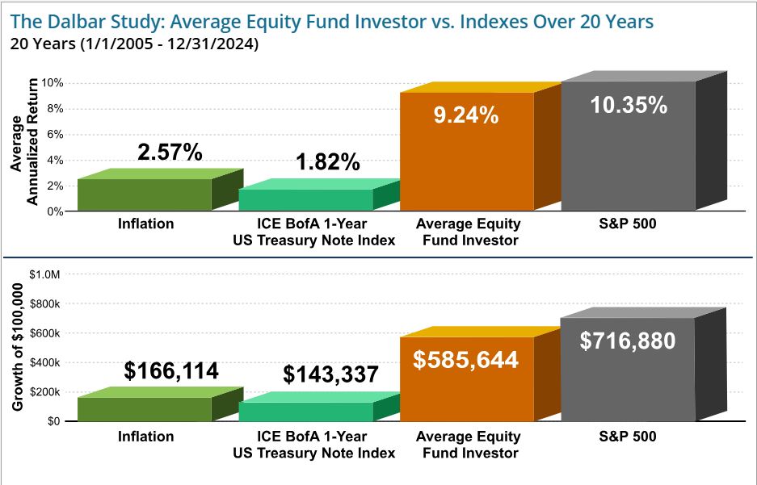
Source: Index Fund Advisors (IFA)
The bottom line: retail investors perform poorly when compared to market benchmarks or index funds tracking the market. A simple strategy of investing in the S&P 500 Index would have yielded better results.

BSE Sensex
The BSE Sensex is the benchmark index of the Bombay Stock Exchange, Asia’s oldest bourse. It is made up of 30 of the most actively traded and financially sound stocks and serves as a reflection of the economy. The composition is reviewed every 6 months.
Since its base date of 1 April 1979, the BSE Sensex has compounded at approximately 15–16% annually, generating an increase of more than 800 times over about 47 years. The CAGR will be higher if dividends were to be included.
On January 1, 2026, the Sensex completed 40 years as the benchmark index. Over its four decades of existence, the index has generated a CAGR of 13.4%.
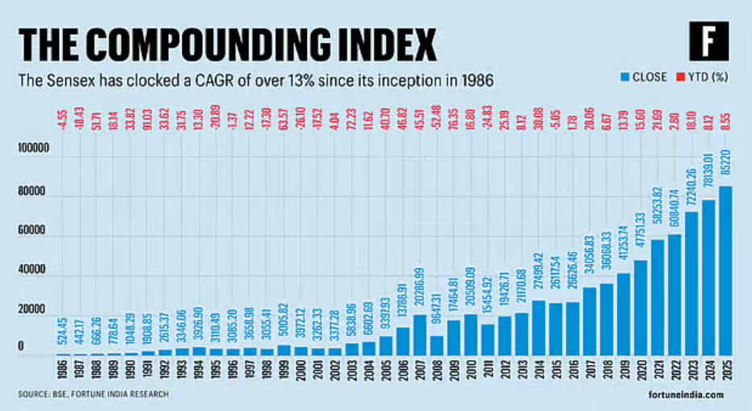
Source: Fortune India
This is better than one would have earned on most forms of financial investments such as bank deposits, corporate deposits and bonds in the same period.

Benefits of investing in index funds
There are several benefits for individuals.

Portfolio selected by experts
The goal of every fund is to deliver the best returns, within the flexibility allowed by its mandate. Much of the effort of fund managers is towards research in the target securities, for the same purpose, delivering the best returns.
With an index fund, the portfolio comes pre-selected, that too by a team of experts appointed by the exchange to determine the composition of its index, or the different indices that it might be monitoring. Whether it is the BSE Sensex, the NSE Nifty50 or any other index, the composition is a process that involves scientific techniques, including back-testing.
The investor can either mirror the chosen index through stock selection on his/ her own, or simply invest the money with a mutual fund that does the same. In both cases, the return will closely mirror the return delivered by the stocks in the index. Doing it individually will deliver a marginally better return, but with the added effort, and possibly cost, of tracking and making changes from time to time.

Lower cost
On account if its nature as a ‘passive’ investment, fund managers do not have to invest much time or effort in researching. This lower cost translates into higher returns for investors.
The following comparison between two funds of the same company, one index based and the other equity growth based, illustrates:
Fund Name | Expense Ratio
SBI Nifty Index Fund Direct Growth | 0.18%
SBI Long Term Equity Fund Direct Growth | 1.07%
HDFC Nifty 100 Index Fund Direct Growth | 0.30%
HDFC Large and Midcap Fund Direct Growth | 1.06%

Diversification
Diversification is an integral strategy in most investing decisions. Investment in an index fund provides the benefit of natural diversification as the index is made up of a variety of assets depending on the index being tracked. Thus, the risk associated with individual stocks is neutralized by the mere act of investing in an index fund.
It must be remembered, however, that the risk mitigation is at the level of the index which the fund tracks. If you invest in a fund that tracks the banking index, cross-industry exposure will not be covered.

Good returns
Finally, the proof of the pudding is in the eating. In other words, how do index funds compare with other types of mutual funds in terms of returns on the money invested.

Conclusion
Index investing is the approach recommended for individual investors. They can invest directly in stocks based on the index composition and keep on adjusting with changes in the index or their own portfolio composition over time. Alternatively, they can follow the strategy by investing in index funds.
Index funds are the recommended approach for individual investors. Sector-agnostic investors could opt for the overall index funds such as the BSE 100 or Nifty 50, while those who have a preference for some specific type of asset could choose a fund tracking that asset or industry, say banking, or consumer goods.
Index funds investment is not a completely passive investment. You would need to choose one among the many types of index-based funds which itself becomes an active choice. The fund needs to be active in ensuring that liquidity requirements are met while maximising returns.
There is often a tracking lag; the delay with which a fund responds to changes in the index composition. Though funds tracking the same index should deliver the same returns over a period of time, this delay could cause some variation in returns.
As is the case in any investing, while they minimise the risk for an investor, index funds are not risk-free. They are exposed to the broad industry movements. For example, in case of an economic downturn when economic activity decreases and all stock stake a beating, index-based funds will also reflect the same behaviour.
Index funds carry tax implications in line with equity-funds. Dividends are included in the taxable income of the investor while income earned at the time of selling the fund is subject to capital gains tax based on the period of holding.

Competitive Financial Markets and the implications for investment strategy
April 3, 2026
Financial markets are very competitive. There are many smart well-resourced players looking to find undervalued securities to buy and overvalued securities to sell. When people find an undervalued security, they buy it and that takes the price higher and when they find an overvalued security, they sell it taking the price lower. A lot of the players are very large institutions with a lot of resources and there are many of them. With lots of people competing furiously to find the mispriced securities, the result is that securities tend to be reasonably efficiently priced. As a result, it is very hard to beat the market.
Historical evidence in the largest market with the most research on historical outcomes, which is the US market, shows that even most professional investors fail to beat the market after costs and fees. If large well-resourced institutions with teams trying to outperform the market have a hard time being successful, it is reasonable to expect that individuals who have much less time, training and resources are likely to fall short. The evidence shows this to be the case. If one accepts this premise that the very competitive nature of markets makes it hard to beat the “market”, the natural implication is that one should not invest a lot of time and resources in picking stocks, picking mutual funds or timing the market because outperforming on any of these dimensions means that one is winning the competitive game to beat most of the other people playing this game. And that, we know, is extremely difficult.

The Evidence
Most institutional investors fall short of properly constructed benchmarks. Here is the evidence from US public Pension funds that manage billions of dollars with the benefit of large professional teams and the ability to hire almost any professional money manager or invest directly. An article by Richard M. Ennis examines the cost, performance, and benchmark bias of public pension funds in the United States.
In its Abstract, the study states: “I estimate that statewide pension funds in the United States incur annual investment expenses averaging 1.3% of asset value. A sample of 24 of them underperformed passive investment during the past decade by an average of 1.4% a year. And yet, those same funds report that they outperformed benchmarks of their own devising by an average of +0.3% a year for the same period. This sharp disconnect raises questions about the usefulness of the funds’ performance reporting, as well as their heavy reliance on expensive active management.”
Most mutual funds fail to keep up with their benchmark indices. This is true in the US and is true in India.
Independent investment research firm Dalbar Inc., an independent research firm, publishes an annual Quantitative Analysis of Investor Behavior report, or QAIB, for retail investors in the US.
It consistently shows that people are “more often than not their own worst enemies when it comes to investing, often succumbing to short-term strategies such as market timing or performance chasing.” It concludes that retail investors perform poorly when compared to market benchmarks or index funds tracking the market.
More details from the report can be accessed in our article: Index investing Strategy.”

Individual or Institution – who you are changes investment choices
If a stock is seen as a good investment opportunity, it is good for you whether you are an individual or an institutional investor. If it goes up, as forecast, all investors benefit. But there are some differences in investment strategies depending on which of these categories you fall into.
Institutions have scale and access to resources often much larger than available to individuals. Their scale can justify an investment in research designed to yield superior returns. It is like an investment in a business activity. By doing so, the investing institution acts like an investment firm that invests others’ money.
Most individuals have limited scale. That scale will only yield limited upsides and downsides, regardless of the amount of time and effort invested in research. For an investment pool of, say ₹ 10 lakh, how many stocks or MFs can you really analyse? If the standard return from an index fund is 10%, you will earn ₹ 1 lakh. A 2% improvement over the market will yield ₹ 20,000 more over a year. You have to ask yourself the question, “Is it worth my while trying to unravel investing mysteries on my own, across thousands of stocks, MFs, Bonds, etc. for that gain? What is my cost of doing that research?”
Individuals should remember that there are many institutions, with access to deep talent pools and resources, with a lot money at stake, trying to do the same thing – generating market-beating returns. They do it as a business. Is it really worth your while trying to outperform the market on your own steam? An institution with a ₹ 100 crore investment pool can hope to generate an extra ₹ 2 crores from the same research, hence might still find it somewhat worthwhile.
On the other hand, individuals have access to a plethora of opportunities that institutions do not. For example, the Indian government offers several savings schemes only for individuals. Strategies for individual investors should almost always look to leverage those opportunities for investors that are better than those available to institutions.

Implications for individual investors
Individual investors should not spend a lot of effort in
- Picking individual securities and funds in an effort to outperform the market
- Timing the market in an effort to outperform the average market performance
Financial markets are very competitive. There are many smart, well-resourced players looking to find undervalued securities to buy and overvalued securities to sell. When people find an undervalued security, they buy it and that takes the price higher and when they find an overvalued security, they sell it taking the price lower. A lot of the players are very large institutions with a lot of resources and there are many of them. With lots of people competing furiously to find the mispriced securities, the result is that securities tend to be reasonably efficiently priced. As a result, it is very hard to beat the market. The historical evidence in the largest market with the most research on historical outcomes, which is the US market, shows that even most professional investors fail to beat the market after costs and fees. If large well-resourced institutions with teams trying to outperform the market have a hard time being successful, it is reasonable to expect that individuals who have much less time, training and resources are likely to fall short.
It can be done without thinking. All you need to do is either match the composition of the index in your stock picks or buy a fund that does the same.
Another way of looking at it is that a team of experts, who have access to more information than we as individuals will ever have, are taking decisions on the composition of the index. Why don’t we put their combined knowledge and skill to work for our own investments? Especially if our ability to bear risk is limited.
Between the Bombay Stock Exchange and the National Stock Exchange, a variety of indices are tracked, with different areas of focus. A variation of the strategy could be to choose one of the other indices and not the primary BSE Sensex.
Of course, it does not mean that the future performance is guaranteed.

The conclusion
If the large institutions are unable to keep up with the market, what should one expect for retail investors as a group?
As an individual investor, do not spend time and resources trying to outperform the market by trying to actively pick individual securities like stocks and bonds or even actively managed mutual funds or time the market, hoping to outperform the average market returns. Instead focus on keeping up and not failing behind average market returns.
Index Strategies do this very well and very efficiently at low cost. Make an exception to the above general strategy only when there are specific situations explicitly giving an advantage to individual investors that are not available to large investors and institutions – small government savings schemes and special tax advantages for individual investors.
If one thinks that one truly can do better than the average market outcomes, then rather than just adding value to one’s personal investment situation, one should really focus on getting a professional position in the investment management industry. The number of people who outperform the average after costs is truly small as has been pointed out in the evidence above. If you truly can be in this small group, you should be able to add a lot of value to professional investors and get paid very well for those results.

Keep the cost of investing low
April 7, 2026
Putting money to work is a task.
Just like you need to make choices between various investment options available, so do the people and institutions you entrust your money to. They have to put the money to work in order that they are able to generate a return from it and share it with you. If they just sit on the money, it will be a loss-making proposition for them.

Putting money to work involves cost
When you deposit money with a bank, they need to lend it out to companies and individuals who will be charged interest which becomes their return, a part of which gets shared with you based on agreed terms. The cost of this effort is factored into the interest rate promised on the deposit.
When you deposit money with a fund, they need to research markets, move money around and make choices in line with the objective of the fund. Many funds charge a management fee to their investors on an annual basis in order to pay for these costs.
Financial advisors also cost money.
Most people have a long investment horizon, from the time they start working, till the time they retire from active work. Annual and other fees over a long horizon become substantial.
Hence, keeping the investment cost low can itself deliver a huge benefit over several decades.

The impact of lower cost investing
Let us take an example of two funds, A and B, that deliver the same return year after year. The management fee charged by one is substantially lower than the other. How does it impact an investor over a period of time?
Table: Comparative earnings difference between funds with different costs
 | Fund A | Fund B
Gross return p.a. | 10% | 10%
Management fee p.a. | 1.25% | 0.25%
Net return to investor p.a. | 8.75% | 9.75%
In 10 years, an initial investment of ₹ 10,000 will amount to | ₹ 23,136 | ₹ 25,354
Investor earnings over 10 years | ₹ 13,136 | ₹ 15,354

Here is another illustration over a longer period of 50 years which demonstrates the additional value created by a fund which costs 1% lower than another similar fund. The initial investment is ₹ 10,000 and the cost difference between the two funds is 1%.
Table: Incremental value created over time
Initial Investment | ₹ 10,000
Investment Period in Years | 50
Investment Return Direct Fund | 10.00%
Additional Fees of Regular Fund | 1.00%
Investment Return Regular Fund | 9.00%
Final Value Direct Fund | ₹ 11,73,909
Final Value Regular Fund | ₹ 7,43,575
Additional Value | ₹ 4,30,333

What do we see?
Taking the higher-cost fund (Regular Fund) as the base case, the lower-cost fund (Direct Fund) has delivered 57% more in terms of gross earnings (₹ 4,30,333 as a percentage of ₹ 7,43,575) to the investor over a 50-year period.
The following table illustrates how the additional value changes over time.
Table: Additional value created over different time horizons
Investment Period in Years | Additional Value (₹)
1 | 100
2 | 219
3 | 360
5 | 719
10 | 2,264
15 | 5,348
20 | 11,231
25 | 22,116
30 | 41,817
40 | 1,38,498
50 | 4,30,333

How to do low-cost investing
Here are some strategies for low-cost investing:
- Choose low-cost index funds
- Choose inactive over active funds
- Choose Direct over Regular funds
- Choose funds with a large corpus so that the management cost is more widely shared and each investor’s share is low
- Avoid frequent trading – each time you trade a transaction cost is incurred
- Choose funds with a history of low management fees
- If you trade directly, use discount brokerages, which typically operate online
- Stay away from high-cost, structured or exotic products
- Maximize post-tax returns through leveraging tax-saving instruments

Conclusion
The objective is not to say that one should ignore high-cost investments even if they are delivering great returns. The objective is to sensitize investors about the material impact on returns that the cost passed on to investors by a fund can have. Hence, it should be part of the variable-set to be evaluated before choosing a fund.

Taxes and their impact on investment outcomes
April 8, 2026
“Nothing is certain but death and taxes” goes the proverb.
Investments are no exception. In most cases the returns earned on investments are treated as income of the investor and taxed one way or another. Hence, the correct way of evaluating returns from an investment is after accounting for taxation. It is not what one earns that matters, but what one gets to keep after taxes.
You may have earned a 10% return, but if you need to pay 30% taxes on the return, what you are left with is only a 7% return, after taking out 30% of 10 which is 3. Holding on to and maximizing gains requires being tax aware.

Tax implications based on type of earning
Interest income – could be added to your income and taxed at the slab rate applicable
Dividends income – currently added to income and taxed at the slab rate applicable. A few years back it was taxed in the hands of the company declaring the dividend with no additional tax liability on shareholders.
Capital gains – such as from shares and mutual funds attract short-term or long-term capital gains tax, based on the holding period

Taxability of different investment instruments
Instrument | Tax Treatment
Fixed Deposits | Interest taxed at slab rate
Equity Mutual Funds | STCG: 15%; LTCG: 10% above ₹1 lakh/year
Debt Mutual Funds | STCG: slab rate; LTCG: 20% with indexation (till 2023 changes)
PPF | Tax-free
NPS | Partial withdrawal tax-free; annuity taxed
ULIPs | Tax-free under Section 10(10D) if premium conditions met

The above are tax implications based on income earned. In addition, certain investments are allowed as deduction from income at the time the investment is made, lowering the income due for income tax, lowering the tax liability. This is mostly the case with what is known as the “old” tax regime. The new tax regime has tried to reduce/ remove the various allowable deductions in order to simplify the tax code.

Factoring taxes into investment decisions

It enables you to
Compare returns accurately – For example, if you are in the 30% tax slab, a tax-free bond offering a 6% return is better than a taxable bond with a return of 7.5%.
Optimize asset location in the family – For example, instruments offering a deduction for investing through the Section 80C route could be purchased by the family member in a higher tax bracket while the lower tax-bracket could purchase other instruments that do not offer this benefit but are needed for meeting allocation and investment goals.
Choose the right Instrument – For example, if you are open to taking equity risk, which is recommended especially at younger ages, you may find that the tax benefits offered by the ELSS mutual funds outweigh the returns from a fixed deposit in a bank.

Quick and simple strategies
PPF, NPS and ELSS are some readily available instruments that provide tax benefits and also enable you to get exposure to equity or debt, based on your allocation and goals.
Capital losses can be used to offset gains in equity portfolios.
Individuals in higher tax slabs should avoid withdrawals from equity schemes in which the slab rate will be applied on gains. Capital gains taxation rate is lower than the income tax rate in the higher slabs.

Conclusion
When people think about investing, they often focus on returns, risk, or diversification. But there’s one factor that significantly impacts your overall wealth and is frequently overlooked: taxes. The difference between a good investment and a great one can come down to how much tax you pay on your gains. Taxes are real, you cannot wish them away. By incorporating taxes into your planning process, you are ensuring greater accuracy in planning and giving yourself a better chance of meeting your investment goals.

When investing in a Mutual Fund, choose a Direct MF over a Regular MF
April 9, 2026
We know that a mutual fund is a pooled investment account that is managed through professional fund managers for the purpose of earning better returns than what individuals may be able to earn on their own. There can be various investment targets for mutual funds depending on their investment objectives. One MF may be focused on the banking sector while another’s goal might be to invest in the technology sector.

Investing in an MF
Every mutual fund scheme can be invested in directly through the fund house, or through a mutual fund distributor, such as your bank, who is an intermediary.
Many investors buy regular mutual funds which are sold through financial intermediaries such as banks. The expense ratio of these funds includes the fees and commissions paid out to these intermediaries for promoting the product. The intermediary provides suggestions to an investor and allows him to choose from a basket of funds that they sell. The investment and disinvestment process is also handled by them.
The other type of mutual fund investment is a direct investment. This investment is done directly with the fund house once an investor has decided upon the fund he wishes to invest in. He needs to evaluate the various options on his own and may not have an intermediary for guidance.
How do you invest directly?
You need to invest through the website of the MF or through branch offices if they have them. Going through a bank or another distributor will get you a regular MF.

How will you know whether your MF is direct or regular?
Direct funds say so in the name. In your statement, the word ‘Direct’ should be a part of the name of the MF scheme. if they don’t say anything, they are regular which sounds good but really means High Fee Class.
Another way to check is the ‘Advisor’ field on the statement. Direct MFs will display ARN followed by a number.

The difference between the two
The difference between the two types of investments arises on account of the total expense ratio (TER) which is loaded on to the fund. It is higher in case of a regular fund, since there is an added component of intermediary fees to pay out, thereby reducing the returns available to the investor. Through the principle of compounding, over time, the difference expands. The TER difference between the two will vary based on the type of fund. Expenses for equity funds are higher, as is the difference.
On account of a lower cost structure, direct MFs are able to pass on a greater share of the earnings back to the investor. Over a long period of time, this difference compounds into a large margin.
It must be kept in mind that the intermediaries provide services to investors such as advice and statements, KYC completion from time to time which may be of use to some investors and they may not mind bearing the extra cost.
To illustrate, the following two tables have been drawn from the Morningstar MF screening tool on the 8th of July, 2025. SBI, one of the largest MF companies in India, reports performance measures for the Direct as well as Regular versions of the same fund.
From the first table we can see that the TER is much higher for the Regular MF when compared to its Direct counterpart.
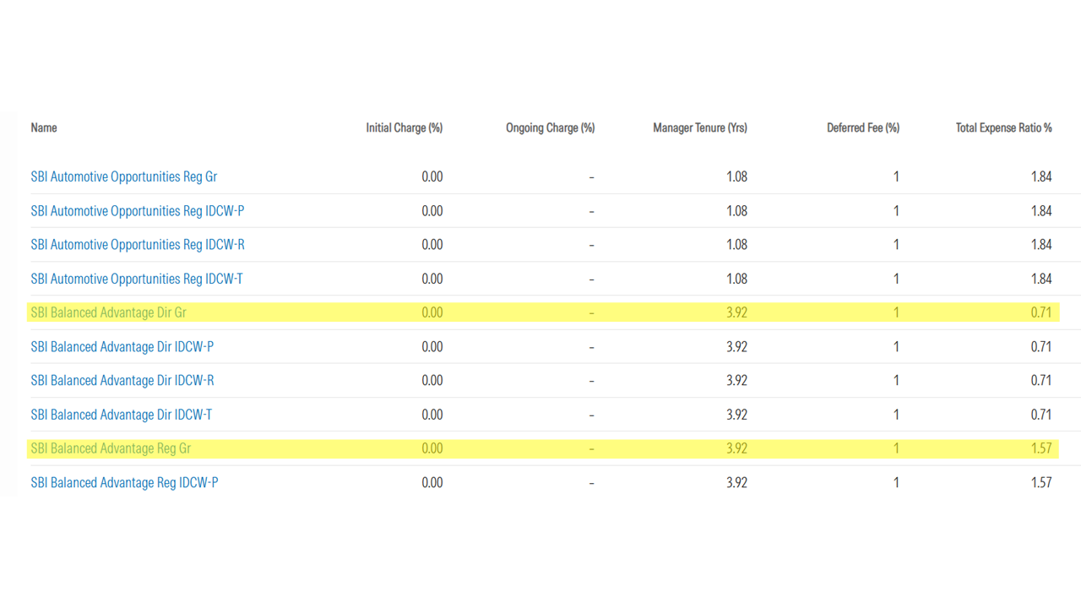
The annual return delivered by the Regular MF is lower than its Direct counterpart, as shown in the second table.
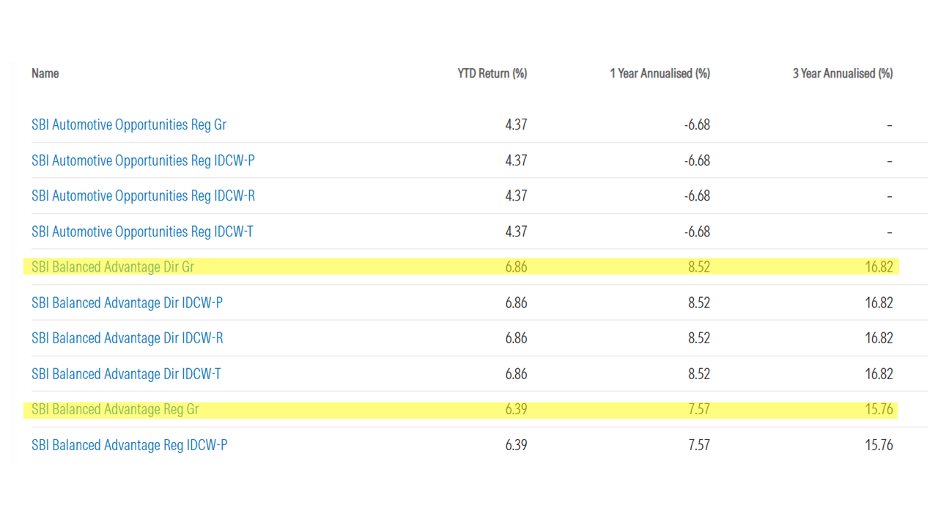
You could check this out for yourself by comparing the Direct and Regular versions of the same MF for other MF companies.

Recommendation
If you are invested in regular MFs, make the move to direct MFs today. Your returns will improve as a result. However, please evaluate the implications prior to initiating the move as a move from a regular to a direct MF is likely to qualify as a sale transaction followed by a purchase transaction and attract applicable capital gains tax and other provisions.
In addition, some services like advice that you were receiving from the distributor will not be available. You will also need to complete the investment related formalities yourself. The focus of MFs is on generating returns, not so much on customer service. However, they will send you account statements if you are a direct investor.
Once you have decided on the type of fund you wish to invest in, look for channels to invest in it as a direct investment.
The following are the website of the some of the largest public sector Mutual Funds for easy reference:
https://www.sbimf.com/
https://www.utimf.com/
https://www.licmf.com/

A liquid mutual fund is better for short-term needs than a bank savings account
April 10, 2026
While the individual investor will have a broad understanding of what a Mutual Fund is, he/ she may not be aware of the range.

What is a liquid fund?
A liquid fund or Liquid Mutual Fund, as the name suggests, invests in highly liquid, short tenure instruments in the money market.
Treasury bills, Certificate of Deposits (CDs), term deposits, commercial papers are some examples of the instruments it could invest in. The objective is to optimize returns while maintaining liquidity and security of the money invested. Redemption requests are normally processed within one working day, highlighting their sensitivity to investor liquidity needs.
Generating high returns is not the primary goal of these funds, which is generally reserved for equity funds. Liquid funds are categorized under debt funds. They park their funds in liquid investments that have a high credit rating and hence a low probability of default. They focus on disciplined investing, which includes ensuring that expenses are kept low while providing liquidity and capital protection to investors.

Benefits of a liquid fund
- Liquid funds are known to offer better returns than a regular savings account.
- They are good for parking surplus money from a few days to a few months, and for keeping your emergency funds in, as they can be released at short notice without having to worry about the present state of the markets.
- Liquid funds provide better post-tax returns compared to keeping money in a savings account and is almost as liquid, except for the overnight redemption period.
- The money is invested in a number of securities as per the mandate of the fund, making it a low-risk investment. Money in a bank account is covered along with other deposit accounts by the standard insurance limit of ₹ 5 lakh.
- Liquid funds are useful when one needs a parking place for funds while a longer-term decision is being processed. It could be when a large sum has been received, such as sale proceeds of a property, or any other similar sudden inflow.
- Investors also use liquid funds while they scout for opportunities in equities and are waiting for a dip to invest.
- Liquid funds can be used for investing in a staggered manner, like an SIP, in an equity fund.
- Liquid funds do not charge an exit load.
- With investments and redemptions going online, it has become progressively easier to invest in them and exit when you deem fit.

Comparison of returns delivered by liquid funds and savings accounts
One can check out the trailing performance of liquid MFs on Moneycontrol.com. A snapshot of the returns delivered by the largest (by AUM) liquid funds is given in the table below:
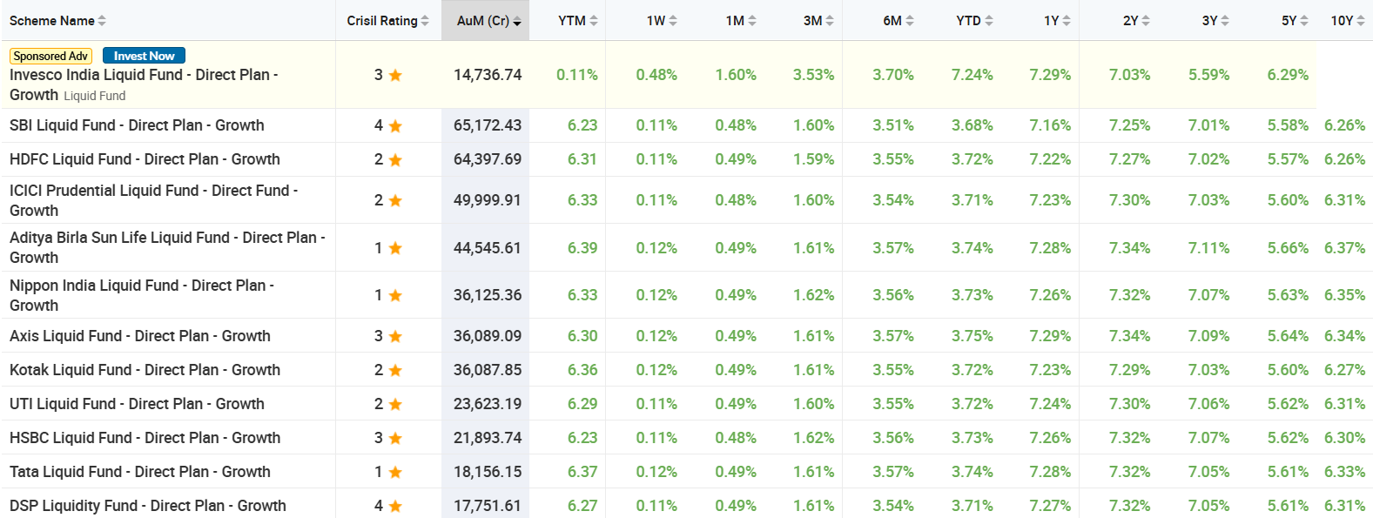
Using State Bank of India as the reference point once again, we note that the current interest rate on savings accounts is 2.5% p.a. The maximum rate offered by SBI between 2000 and 2019, as displayed on their website, was 4% p.a.
Thus, liquid MFs are a better option for investors looking for safe returns for a short period of time.

Recommendation
Move excess funds from a bank savings account into a liquid mutual fund.
Choose a Direct Liquid Fund offered by one out of the following biggest providers – SBI, HDFC, ICICI, UTI and LIC. The benefit in choosing a big fund is that the expenses get absorbed over a larger corpus, reducing the dilution of return for each investor.

National Pension System (NPS)
April 11, 2026
The National Pension System (NPS) is a pension cum investment scheme launched by the Government of India to provide old age security to citizens of India. The scheme is regulated by the Pension Fund Regulatory and Development Authority (PFRDA). It is a good option for non-organized workers, including small business owners, who do not have access to any organized form of pension through an employer.
It is open to all residents, as well as NRIs (with some restrictions) and seeks to provide market-based returns over the period of investment and an annuity from the time the investment period ends. It is a low-cost scheme that limits the management fee that can be charged by the chosen fund, based on its AUM.
The primary account is called the Tier I account. An optional, and related, Tier II account, also known as an investment account, can also be opened, with some differences.
 | Tier 1 | Tier 2
Mandatory | Yes | No
Contribution | Minimum amount per contribution - ₹ 500  Minimum contribution per Financial Year - ₹ 1,000  Minimum number of contributions in a Financial Year – one | Minimum amount per contribution - ₹ 250  Not mandatory to contribute every year
Withdrawal | Restricted to death and reaching retirement age | Flexible withdrawal
Further:
– There is no additional cost for maintaining a Tier II account
– Tier II amounts can be invested in the same manner as Tier I
– Tier II can only be maintained along with a Tier I account
Investment and Exit are the two distinct parts of the scheme.

Investment
Individual savings are pooled in to a pension fund which are invested by PFRDA regulated professional fund managers as per the approved investment guidelines in diversified portfolios comprising Government Bonds, Bills, Corporate Debentures and Shares. These contributions would grow and accumulate over the years, depending on the returns earned on the investment made. Investors can choose the investment scheme and also switch from one manager to another.

Pension Fund Manager (PFM) under NPS:
Subscriber is mandatorily required to choose one PFM from the available PFMs:
- Aditya Birla Sunlife Pension Management Limited
- Axis Pension Fund Management Limited
- HDFC Pension Management Company Limited
- ICICI Prudential Pension Funds Management Company Limited
- Kotak Mahindra Pension Fund Limited
- LIC Pension Fund Limited
- SBI Pension Funds Private Limited
- Tata Pension Fund Management Pvt. Ltd.
- UTI Retirement Solutions Limited
- DSP Fund Managers Pvt. Ltd.
This list is as in June 2026 and can be changed by the NPS Trust.
The contribution remitted in Subscriber’s account is passed on to the PFMs as selected by the Subscriber at the time of registration (or changed subsequently). The PFMs invest the money and declare Net Asset Value (NAV) at the end of each business day. Accordingly, based on the NAV, units are credited in the Subscriber’s account. The present value of the investment is arrived at by multiplying the units held with the NAV.
The return under NPS is market driven. Hence, there is no guaranteed/defined amount of return. The returns generated through investments are accumulated for the pension corpus and are not distributed by way of dividend or bonus.

Investment Options
Investors can choose where funds are invested or opt for the Auto choice, under which funds are automatically allocated amongst asset classes in a pre-defined matrix, based on the age of the subscriber.

Asset Classes
Investors can choose the asset classes where their funds will be invested and the fund manager to whom they entrust their funds will allocate them in that proportion. These options are:
- Equity – Asset Class E
- Corporate Debt – Asset Class C
- Government Securities – Asset Class G
- Alternative Investment Funds or AIF – Asset Class A
The following conditions apply:
- Subscriber can select multiple Asset Class under a single PFM
- Upto 50 years of age, the maximum permitted Equity Investment is 75% of the total asset allocation.
- From 51 years and above, maximum permitted Equity Investment will be as per an equity allocation matrix that reduces with age, going to 50% for 60 years and above.
- Percentage contribution value cannot exceed 5% for Alternative Investment Funds.
- The total allocation across E, C, G and A asset classes must be equal to 100%.

Choices available
Investors can allocate their funds in the following ways:

Active choice
Unlike traditional investment products, NPS offers you with the flexibility to design your own portfolio. Depending on your risk appetite, you can design your portfolio by allocating Funds amongst available four asset classes.

Auto Choice
At times designing your portfolio can be a little delicate and time consuming. NPS gives you the flexibility to opt for a dynamic and automatic allocation of your portfolio in case you do not want to exercise an Active choice. This option is called the Auto choice.
In Auto choice, your money will be invested in asset classes E, C and G in defined proportions based on your age. As individual’s age increases, exposure to Equity and Corporate Debt is gradually reduced and that in Government Securities is increased. Depending upon the risk appetite of subscriber, there are three different options available within Auto Choice-Aggressive, Moderate and Conservative.
Aggressive (LC-75) – Maximum Equity exposure is 75% up to the age of 35
Moderate (LC-50) – Maximum Equity exposure is 50% up to the age of 35
Conservative (LC – 25) – Maximum Equity exposure is 25% up to the age of 35

Performance history
10-year trailing returns (% p.a.) delivered by various Pension Fund Managers for the E (Equity) Scheme over a 10-year period ending on 11th July, 2025, as published by the, are shown below:
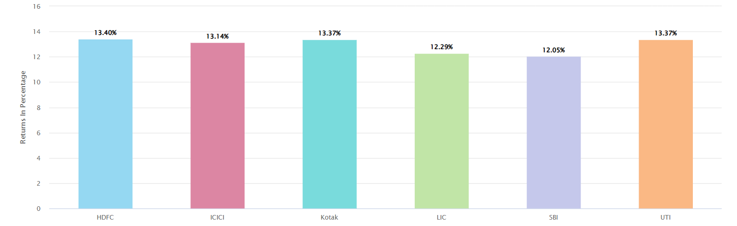
The scheme has added a few more providers during this period who have yet to complete 10 years.
Trailing 7-year returns from the NPS Trust website under the 4 fund options offered by NPS are also summarized below:
Scheme --> | E | C | G | A
HDFC Pension Fund Management Ltd. | 14.80% | 8.98% | 8.60% | 9.46%
ICICI Pru. Pension Fund Mgmt Co. Ltd. | 15.03% | 8.62% | 8.54% | 8.37%
Kotak Mahindra Pension Fund Ltd. | 15.39% | 8.06% | 8.58% | 8.22%
LIC Pension Fund Ltd. | 14.35% | 8.62% | 9.18% | 8.20%
SBI Pension Funds Pvt. Ltd | 13.12% | 8.68% | 8.67% | 9.89%
UTI Pension Fund Ltd. | 14.80% | 8.32% | 8.40% | 7.89%
Benchmark | 15.18% | 8.96% | 8.78% | NA

Risk
The investment can be considered as a very-low-risk investment as it is offered by a government agency, which equates to sovereign risk. However, certain asset classes such as equity could result in sub-optimal outcomes as they are market dependent and not committed returns.

Exit
On retirement or exit from the scheme, the Corpus is made available to the subscriber with
the mandate that some portion of the Corpus must be invested in an annuity to provide a
monthly pension post-retirement or exit from the scheme. At least 40% of Tier I balance
should be so invested. The balance can be withdrawn as a lump sum without tax implication.
It can also be invested in the annuity purchase along with the mandatory 40%.
Tier II balance can be fully withdrawn. It can also be transferred to Tier I account at any point
during the currency of the account or at the time of exit, without incurring any exit load.

Annuity purchase
Annuity purchase at the time of exit can be done out of a set of choices offered by the PFMs.
Once purchased, providers cannot be changed once the free look-in period is over. Annuity
returns can vary from one provider to another. The choices available:

Annuity for Life with Return of Purchase Price
Subscriber will get annuity for life time and on death of the Subscriber, payment of annuity
ceases & 100% of the purchase price will be returned to the nominee(s).

Annuity for Life without Return of Purchase Price
Subscriber will get annuity for life time and on death of the Subscriber, payment of annuity
ceases and no further amount will be payable.

Joint Life Annuity with Return of Purchase Price
Subscriber will get annuity for life time and on death of the Subscriber, annuity will be
payable to Spouse for life time. On death of the Spouse, payment of annuity ceases and
100% of the purchase price will be returned to the nominee(s).

Joint Life Annuity without Return of Purchase Price
Subscriber will get annuity for life time and on death of the Subscriber, annuity will be
payable to Spouse for life time. On death of the Spouse, payment of annuity ceases and no
further amount will be payable.

Family Income Option with Return of Purchase Price
Subscriber will get annuity for life time and on death of the Subscriber, annuity will be
payable to spouse of the Subscriber (if any) for life time. On death of Spouse, to dependent
mother and then to dependent father of the Subscriber. On death of the last annuitant, payment of annuity ceases and 100% of the purchase price will be returned to the surviving children of the Subscriber and in absence of children, the legal heirs of the subscriber as applicable.

Tax implications
(Available only for contributions to Tier I accounts)
Contributions eligible for tax benefit under Sec 80 CCD (1) with in the overall ceiling of ₹ 1.5 lakh under Sec 80C.
An additional deduction for investment up to ₹ 50,000 in NPS (Tier I account) is available exclusively to NPS subscribers under subsection 80CCD (1B).
Note: This deduction continues to be provided in the new tax regime.
Subscriber can partially withdraw from NPS Tier I account for specified purposes. Amount received from partial withdrawal are tax exempt u/s 10 (12B) of Income Tax Act.
Amount invested in purchase of Annuity, is fully exempt from tax. However, annuity income that you receive in the subsequent years will be subject to income tax.
Up to 60% of the total corpus withdrawn in lump sum at the time of exit is exempt from tax.
Note: These provisions on withdrawal of funds from the scheme continue to be applicable in the new tax regime.

Example
If total corpus at exit is 10 lakhs, then 60% of the total corpus i.e. 6 lakhs, you can withdraw without paying any tax. So, if you use 60% of NPS corpus for lump sum withdrawal and remaining 40% for annuity purchase, you do not pay any tax at that time. Only the annuity income that you receive in the subsequent years will be subject to income tax as per the applicable tax slab.

Liquidity
Subscribers can withdraw certain parts of the investment starting 3 years after joining. No penalty on withdrawal.

Recommendation
Should be subscribed by everyone who is eligible.
Investment options as well as Annuity options made available under the NPS scheme, are also available through the same, and other, private players without going through the scheme.
The benefit of NPS over private players on the investing side is that the expense ratio of these funds is lower than privately managed (outside the NPS) funds.

Bank Fixed Deposits
April 12, 2026
A sum of money placed with a bank for a defined period of time is known as a Fixed Deposit (FD). A Fixed Deposit is easy to use as it can be transacted at any commercial bank. Most people will have at least one banking relationship. For them, an FD has been a first-choice investment as and when they have had money that they could be put away.
Banks have promoted FDs as it provides them greater certainty of funds at a relatively low rate. It is now also possible to open and close FDs through the online service offered by banks which could, earlier, only be done through bank branches.
A bank FD is considered to be a baseline investment in India. Hence, all other investment options can be considered as competition. In any case, a Bank FD competes with Bank FDs offered by all other banks. Anyone (including NRIs, with certain specific conditions) can open an FD with any commercial bank in India.

Interest rate
The rate of interest offered by banks keeps changing with changes in market conditions and their own liquidity needs. That being said, rates offered by most banks are generally aligned at most times.
FD rates offered by State Bank of India, the nation’s largest bank, in July 2025 are presented below as a sample and can be accessed through this link:
Table: State Bank of India FD interest rates as on 4th June, 2026
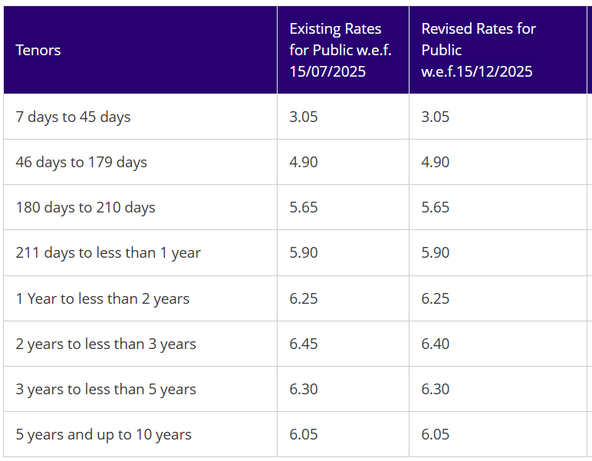
Most banks offer 0.50% higher interest to senior citizens.

Risk
Deposits in all commercial banks (including foreign bank branches in India) and cooperative banks are insured up to ₹ 5 lakh per depositor per bank by the Depositor Insurance and Credit Guarantee Corporation (DICGC).
While there have been failures of private banks and cooperative banks, no scheduled commercial bank has failed in India in the last 50 years.
You can learn more about deposit insurance on the DICGC website and ensure that your bank is on the covered list before you place a deposit with them.

Liquidity
Fixed Deposits are considered liquid, as they are permitted to be withdrawn prematurely. The general rule followed by most banks is that of a 1% penalty. In other words, the interest paid on premature withdrawal will be 1% lower than the rate applicable for the period for which the FD has run, as offered on the date of placement. In general, as higher rates tend to be offered for longer tenures, premature withdrawal mostly results in a 1% deduction from a rate that islikely to be lower than the contracted rate.
Some banks link the FD to a savings account. Any shortfall in funds in the savings account is replenished by uplifting a portion of the linked FD. This, in a way, means that the depositor earns FD rates while having the flexibility of withdrawal as per a savings account.

Pros and Cons
+ Easy to deposit and withdraw
+ Rate is slightly lower than government schemes, but competitive
+ No amount limitation; any amount can be deposited
~ Income is fully taxable, at the slab rate applicable to the depositor
~ Commercial organization risk with insurance only up to ₹5 lacs

Recommendation
Limit investment to insured limit and check for insurance coverage.
Bank with established banking organizations or with government-owned banks.

Government Bonds
April 13, 2026
A Government Bond is a debt instrument issued by the Central or a State government for the purpose of mobilizing public money, usually for the purpose of financing infrastructure projects. The authority issuing the Bonds is responsible for redeeming them, or paying the interest and maturity proceeds of the instrument. As the purpose usually is to finance infrastructure development, the maturity periods can be long, usually between 5 and 40 years.
They are also known as government securities (G-Secs) and GILTs. Individual investors can directly invest in these instruments, subject to the stipulations and requirements of each issue.
They are investments that are guaranteed by the issuing government authority and could be considered as one of the safest forms of investment. Hence, they are ideal investments for risk-averse investors.

Types of Bonds
Both the central and state governments can issue bonds of different types.

Fixed-rate bonds
This is the most common type. The rate remains fixed during the period of existence of the bonds. The interest rate is known as the coupon rate.
For investors buying and selling Bonds in the secondary market, the value can change based on market conditions. During inflationary conditions, if interest rates for competing investments rise, the face value of the bonds will decline to a level where the coupon rate, which is fixed, becomes competitive. And vice versa.

Floating Rate Bonds (FRBs)
The rate is not fixed for the entire tenure but keeps changing based on a pre-determined formula as well as the intervals at which the change would be effective.

Sovereign Gold Bonds (SGBs)
These bonds are a method of attracting investments from the public that would normally go into physical gold or gold assets such as jewellery, as has been the tradition in India. These bonds are pegged to the value of gold and also pay a small interest on the investment.
Hence, investors will not only get value on maturity based on the appreciation (or depreciation) in gold prices, which they would be subject to even if they had invested in physical gold. In addition, they will also receive interest, which they would not in case of physical gold. These are also exempt from capital gains tax in the hands of individuals.

Inflation-Indexed Bonds
These are specifically meant for retail investors and seek to deliver a return that compensates them for the rise in prices during the currency of the bond.
Mostly indexed to the Consumer Price Index (CPI), the purpose is to provide a constant return to investors, taking inflation into account.

Treasury Bills (T-Bills)
Bonds issued for under a year are known as T-Bills.

7.75% GOI Savings Bond
Designed as a high-return Bond as compared to several others in existence, this instrument is reserved for investment by resident individuals.
Interest earnings from such bonds are taxable under the Income Tax Act 1961 as per the investors’ applicable income tax slab. The minimum amount at which these bonds are issued is ₹ 1000 and in multiples of ₹ 1000 thereof.
Tax free Bonds
Certain public sector entities get permission to issue tax-free bonds, for raising money for projects of particular importance. These are attractive investments for people with large taxable incomes as it gives them one source of income that is not taxable.
Zero coupon Bonds
These are issued at a discount, without any attached coupons. The face value is paid to the investor on redemption at maturity. The difference between the buying and selling prices becomes the earning for the investor.

Advantages and disadvantages of investing in Government Bonds
- Government Bonds are virtually risk-free as they are issued by the Central and State governments.
- Interest earned on Bonds are disbursed to holders at regular intervals, as specified in the terms of issuance usually 6 months. This becomes a source of regular income for investors without exposure to market-related movements.
- Liquid investment. It is a tradeable security and can be sold at prevailing prices without delay and without penalty.
- Bonds are subject to rate fluctuations.

How can individuals buy and sell Government Bonds?
Individuals can invest in Bonds through multiple channels.

Direct Investment
As Bonds are market securities, they can be bought and sold on the marketplace, similar to buying and selling stocks.
While traditionally buying and selling of securities was conducted through brokers, with online trading gaining ground, interested individuals can open a trading account and a demat account (where the bought security will be deposited) through a broking house and conduct purchase and sale of Bonds.

Directly through the NSE goBID bidding process
Individuals can participate in the non-competitive bidding (NCB) process through which bids can be placed online at the time of fresh issuance of Bonds. This is akin to investing in share IPOs. This can be done through the goBID web portal of the NSE. The government determines the yield based on the bids received. You will need to register/ create an account for this bidding.

RBI Retail Direct
Since November 2021, individuals can invest in G-Secs through the Retail Direct Gilt (RDG) process of RBI, which allows you to participate in primary issuance.

Focused Mutual Funds
Investment in Government Bonds can also be made through Mutual Funds that focus on this investment product. Though an indirect channel, this has gained popularity amongst individuals, just like Equity MFs have gained traction with individuals, as opposed to direct investment. These MFs are also referred to as GILT-edged MFs.

Historical returns
Returns delivered by a few of the large GILT mutual funds as available on the moneycontrol.com website, as on 11th July, 2025:

Scheme Name | AuM (Cr.) | 1Y | 5Y | 10Y
SBI Magnum Gilt Fund - Direct Plan - Growth | 12,148.74 | 8.66% | 6.52% | 8.65%
ICICI Prudential Gilt Fund - Direct Plan - Growth | 7,275.51 | 10.21% | 6.89% | 8.82%
Kotak Gilt - Investment - PF and Trust - Direct Plan - Growth | 3,809.82 | 7.99% | 6.35% | 8.44%
Kotak Gilt - Investment - Direct Plan - Growth | 3,809.82 | 7.99% | 6.35% | 8.41%
Bandhan Government Securities Fund - Investment Plan - Direct Plan - Growth | 3,123.96 | 7.45% | 5.91% | 8.48%
HDFC Gilt Fund - Direct Plan - Growth | 3,045.35 | 9.40% | 5.80% | 7.45%
Aditya Birla Sun Life Government Securities Fund - Direct Plan - Growth | 2,463.18 | 8.03% | 6.09% | 8.53%
Nippon India Gilt Fund- Direct Plan - Growth | 2,063.18 | 8.67% | 5.93% | 8.83%
Nippon India Gilt Fund- Direct Plan - Automatic Capital App | 2,063.18 | 8.67% | 5.93% | 8.83%
DSP Gilt Fund - Direct Plan - Growth | 1,852.40 | 8.61% | 6.48% | 8.56%

Conclusion
Government Bonds are a part of the Fixed Income type of investments that earn on the basis of pre-determined rates or formulae and are not dependent on market conditions. Hence, the usual suspects will be:
- Government schemes such as PPF and SCSS
- Bank Fixed Deposits
- Corporate debentures
Government Bonds are a good investment for a portion of the investible amount of individuals, where risk-avoidance is a primary condition.
The Indian government has made it progressively simpler for individuals to invest through online channels in primary issues, as well as a robust secondary market through trading and demat accounts.

Government Savings Schemes
April 14, 2026
The government offers a number of investment options for the individual investor. On account of a lack of awareness about these schemes (many money managers may not suggest these schemes as they do not receive a commission) as well as hesitation in dealing with a machinery that is considered bureaucratic and slow, many eligible people do not invest in them.
The loss is their own as these schemes offer great returns, better than fixed income schemes like fixed deposits and bonds, the highest level of security, and tax benefits as well. With online access to account opening and closing gradually expanding, it is also becoming easier to invest in these schemes.
A short list of schemes that you should consider, along with their key features, as currently applicable, are shared below. We hope this will encourage more of you to consider investing in government schemes. The returns, tax implications and features are subject to change. As always, please read the scheme documents to ensure that they are beneficial for your situation.
Table: Government savings schemes for individuals
Scheme | Target Group | Returns (Indicative) | Tenure
Public Provident Fund (PPF) | All individuals. Account can be opened till the age of 75. | 7.1% (compounded yearly) | 15 years
National Savings Certificate (NSC) | All individuals | 7.7% | 5 years
Sukanya Samriddhi Yojana (SSY) | Girl child (age <10) | 8.2% | Till age 21 or marriage at 18
Senior Citizens Savings Scheme (SCSS) | Age 60+ (or 55+ retired) | 8.2% (paid out quarterly) | 5 years (extendable)
Kisan Vikas Patra (KVP) | All individuals | 7.5% (principal doubles on maturity) | 115 months
National Pension System (NPS) | All Indian citizens (18–70) | Market-linked | Purchase annuity on attaining the age of 60, or delay it.
RBI Floating Rate Savings Bonds | All individuals | ~8.05% (Jul–Dec 2025) | 7 years

The National Savings Institute publishes the applicable rates for different schemes on its website.
An overview of the schemes is also available here.
With this list, you can pick the one with the highest rates subject to your liquidity preferences and taxability, till you get to the maximum and then move to the next option.
Details of the National Pension System (NPS), Public Provident Fund (PPF), and Senior Citizens’ Saving Scheme (SCSS) can be accessed on this website by clicking on the names of these schemes here.

Things to note
- While it is recommended that you go through the scheme details to ensure it suits your requirements, the following are a quick reckoner which apply to most:
- Extremely low or negligible risk as offered by the government of India
- Available through Post Offices, public sector banks and designated private banks
- Age and other restrictions may apply to account opening as well as to withdrawal and closure
- Minimum and maximum annual investment amounts are applicable to most
- Check for tax benefits available on the amount invested and the interest earned, especially under the old income tax system
- Interest rates are subject to change on a quarterly or annual basis

Senior Citizen Saving Scheme (SCSS)
April 23, 2026
The Senior Citizens Savings Scheme (SCSS) account is designed to offer superior returns to senior citizens, along with security of the money. It could be viewed as a retirement benefit account as it is only available to people above 60, with some exceptions. Along with excellent returns and safety, the account also offers tax benefits.
By paying out interest every quarter to a designated account, the scheme fulfils one of the primary objectives of the scheme of providing regular income for seniors.
The account can be opened with the Post Office or with designated public and private sector banks.
With banks offering the facility of opening and closing the account online, it has become easier to open this account for people who have shied away from transacting at post offices.

Benefits
The return offered SCSS is 8.2% currently and is the highest amongst all assured-return, government guaranteed schemes if you look at the comparative returns of all schemes under the section on government schemes.
Historically, SCSS has offered attractive rates of interest, as demonstrated by the historical table below:
From | To | Interest Rate
1 Apr 2015 | 31 Mar 2016 | 9.30
1 Apr 2016 | 30 Sep 2016 | 8.60
1 Oct 2016 | 31 Mar 2017 | 8.50
1 Apr 2017 | 30 Jun 2017 | 8.40
1 Jul 2017 | 30 Sep 2018 | 8.30
1 Oct 2018 | 30 Jun 2019 | 8.70
1 Jul 2019 | 31 Mar 2020 | 8.60
1 Apr 2020 | 30 Sep 2020 | 7.40
1 Oct 2022 | 31 Dec 2022 | 7.60
1 Jan 2023 | 31 Mar 2023 | 8.00
1 Apr 2023 | 30 June 2026 | 8.20
The interest earned on the account is added to the account holder’s taxable income for the year.
Being a government scheme, it offers the highest level of security to account holders.

Features
An account can be opened with a minimum of ₹ 1,000. The account operates like a Fixed Deposit. Once opened, you cannot add or subtract from it. At the time of closure, the full amount has to be withdrawn.
Multiple accounts can be opened subject to a maximum limit of ₹ 30 lakh at any point of time in the name of a depositor.
An account holder may operate more than one account under this Scheme subject to the condition that the deposits in all the accounts taken together shall not exceed the maximum limit of ₹ 30 lakh.
The account can be opened by a person who has reached the age of 60. This is lowered, with some conditions, to:
- 55 for people who have retired under Superannuation, VRS or Special VRS.
- 50 for retired Defence Services personnel
Interest is paid on the first working day of the calendar quarter for the previous quarter.
On expiry of the account on completion of 5 years, the account can be closed or extended for another 3 years. After closure a SCSS account can be opened once again, if needed.
The SCSS is closest in its method of operation to Fixed Deposits. You can place money in an account only once, after which it keeps paying you interest every quarter. The rate of interest is determined on the day you open an account and remains unchanged during the period the account is live, unlike a PPF account where the updated interest rates are applicable on the entire balance in the account.

Recommendation
It should be considered by everyone who is eligible. The account can be opened at Post Offices and designated commercial banks.

Public Provident Fund
May 23, 2026
The Public Provident Fund (PPF) scheme is a savings scheme conceptualised by the National Savings Institute and offered by the government of India. It provides handsome returns along with tax benefits. However, the new income tax code which seeks to simplify the process, has done away with some of the benefits available on account of investing in specified schemes. Hence, please ascertain the tax implications prior to investing.
The rate of interest is subject to change quarterly; however, the change generally happens annually. Accounts can be opened with the Post Office as well as with public sector and designated private banks.
While pension funds create regular income after retirement, provident funds yield a lumpsum amount at or around the time of retirement. Non-organized workers, including small business owners, do not have access to any organized form of getting such a lumpsum amount except for their own savings.
The PPF scheme creates a high-yield and tax-efficient scheme where small savings can be accumulated over a period of time and which can provide the account holder with a lumpsum value at a later date.

Benefits

Attractive rate of interest
The PPF account offers a handsome rate of interest which is determined every year by the Ministry of Finance – Department of Economic Affairs, along with the rates for all the other National Small Savings Schemes. Since April 2020, the rate of interest has remained unchanged at 7.1%.
Historically, the rate on PPF accounts has been 25 basis points, or more, higher than the yield on Government bonds of similar maturity, with a variety of factors taken into account by the government while determining the rate.
Historical rates for the past 10 years:
From | To | Interest Rate
1 Apr 2013 | 31 Mar 2016 | 8.70
1 Apr 2016 | 30 Sep 2016 | 8.10
1 Oct 2016 | 31 Mar 2017 | 8.00
1 Apr 2017 | 30 Jun 2017 | 7.90
1 Jul 2017 | 31 Dec 2017 | 7.80
1 Jan 2018 | 30 Sep 2018 | 7.60
1 Oct 2018 | 30 Jun 2019 | 8.00
1 Jun 2019 | 31 Mar 2020 | 7.90
1 Apr 2020 | 30 Jun 2026 | 7.10

PPF rates have, at almost every point in time in the last 10 years, been higher than the highest rates offered on Fixed Deposits by government banks.
It must, however, be noted that the interest applicable is evaluated and declared every quarter by the Ministry of Finance, as is also done for a number of other savings schemes. The declared rate is applicable to the entire balance in the account.

Tax benefits
Deposits into the account qualify for deduction under Sec.80-C of IT Act, a part of the overall ceiling of ₹ 1,50,000. However, the updated IT code, adopted by most filers, does away with this benefit.
Interest earned on the account is free from Income Tax under Section -10 of the IT Act.
Withdrawals from the account are free from any taxation liability.
These make the PPF account extremely tax efficient, and superior to fixed deposits in banks and most other government schemes.

Free from attachment
The amount in a PPF account cannot be attached under any court decree or law, making it highly secure for the account holder.

Features
- An account can be opened for a minimum value of ₹ 500-. The maximum that can be deposited during a financial year in an account is ₹ 1,50,000-. If, perchance, more does get deposited, it will not earn any interest.
- It can only be opened by resident Indian individuals.
- Interest is calculated on a monthly basis on the minimum balance between the 5th and last day of the month and paid at the end of the year.
- A minimum deposit needs to be made every year the account is live.
- Loans can be taken against the account from the 3rd year onwards up to the 6th year. From the 6th year, partial withdrawals can be made.
- The account can be maintained for a period of 15 years. On maturity after 15 years, it can continue to be extended in blocks of 5 years at a time, for any number of such blocks.
- Account holders also have the option of retaining the account after maturity without further transactions, but earning interest on the balance held at maturity, at prevailing rates.
- Premature closure of the account is possible 5 years after opening, in certain situations such as treatment of life-threatening conditions, higher education and change in residency status. In the event of such a premature closure, the rate of interest will be 1% lower than the rate at which interest credits have been given.

Recommendation
Should be subscribed by everyone who is eligible.

Equity Linked Saving Scheme (ELSS)
July 20, 2026
It is a type of mutual fund scheme primarily investing in equity and equity-related instruments, and it offers tax benefits under Section 80C of the Income Tax Act, 1961.

Features
- A minimum of 80% of the total investible corpus is invested in equity and equity-related instruments
- The fund invested in equity in a diversified manner – across different market capitalization, themes and sectors.
- There is no maximum tenure of investment. However, there is a lock-in period of 3 years.
- Tax exemption on the invested amount available under section 80C upto ₹ 1.5 lakh.
- Income is treated as Long Term Capital Gain and taxed as per the prevalent tax rules. These gains are tax-free up to ₹ 1 lakh per year, and any earnings beyond this amount are subject to a 10% long-term capital gains tax.
- It allows the investor to start investing as low as ₹ 500.
- It allows the investor to invest in lumpsum amount or in the form of SIPs.

Return and Risk
ELSS funds carry higher risk compared to traditional tax-saving options like PPF and NSC due to their equity exposure. However, they also offer the potential for higher returns over the long-term, aligning with the higher risk-reward profile of equities.
The strategy of diversification across companies and sectors helps in mitigating the risk to some extent. However, the inherent risk present in equities as an investment class continues.

ELSS vs NPS
 | ELSS | NPS
Nature of investment | A type of mutual fund that primarily invests in equity and equity-related instruments. It offers the potential for high returns but also carries higher market risk due to equity exposure. | A government-sponsored pension scheme that offers a mix of equity, corporate bonds, government securities, and alternative assets. It is designed for retirement planning and offers a diversified portfolio with varying risk profiles based on the investment option
Tax implications | Investments qualify for tax deductions under Section 80C of the Income Tax Act, up to a maximum of ₹1.5 lakh in a financial year. Additionally, long-term capital gains (LTCG) up to ₹1 lakh from ELSS are tax-exempt. | Contributions to NPS Tier I account qualify for tax deductions under Section 80CCD(1) within the overall limit of ₹1.5 lakh under Section 80C. An additional deduction of up to ₹50,000 is available under Section 80CCD(1B). Withdrawals from the mandatory NPS Tier 1 are not taxed.
Lock-in period | ELSS has a lock-in period of three years, which is the shortest among tax-saving investment options under Section 80C. | NPS has a longer lock-in period, with investments in the Tier I account being locked in until retirement age, although partial withdrawals are allowed under certain conditions.
Flexibility | ELSS offers flexibility in terms of investment amount and withdrawal options after the lock-in period. Investors can choose to invest through lump-sum or systematic investment plans (SIPs). | NPS offers flexibility in choosing investment options, allocation among asset classes, and fund managers. Withdrawals from the Tier I account are restricted, with conditions attached. Withdrawals can be freely made from the Tier 2 account.

Comparison of returns

ELSS
Trailing returns delivered by the 10 largest funds 9(by AUM) as per data tracked by Moneycontrol.com:
Scheme Name | AuM (Cr) | 1Y | 5Y | 10Y
Axis ELSS Tax Saver Fund - Direct Plan - Growth | 36,257.53 | 5% | 18% | 13%
SBI ELSS Tax Saver Fund - Direct Plan - Growth | 30,616.22 | 3% | 28% | 15%
Mirae Asset ELSS Tax Saver Fund - Direct Plan - Growth | 26,537.48 | 6% | 24% | -
DSP ELSS Tax Saver Fund - Direct Plan - Growth | 17,427.57 | 5% | 26% | 17%
HDFC ELSS Tax saver - Direct Plan – Growth | 16,908.00 | 7% | 27% | 14%
Aditya Birla Sun Life ELSS Tax Saver Fund - Direct Plan - Growth | 15,869.72 | 4% | 16% | 12%
Nippon India ELSS Tax Saver Fund - Direct Plan - Growth | 15,623.15 | 1% | 25% | 11%
ICICI Prudential ELSS Tax Saver Fund - Direct Plan - Growth | 14,660.64 | 5% | 23% | 14%
Quant ELSS Tax Saver Fund - Direct Plan - Growth | 11,922.65 | -9% | 33% | 22%
Canara Robeco ELSS Tax Saver Fund - Direct Plan - Growth | 9,102.87 | 4% | 23% | 15%

NPS
Trailing returns (% p.a.) delivered by various Pension Fund Managers for the Tier 1 E (Equity) Scheme over a 10-year period ending on 11th July, 2025, as published by the NPS Trust, are shown below:
Pension Fund | AUM  (₹ Crs) | 1 Year | 5 Years | 10 Years
Aditya Birla Sun Life Pension Fund Management Limited | 1,746.66 | 3.42% | 20.03% | NA
Axis Pension Fund Management Limited | 4,266.92 | 3.07% | NA | NA
HDFC Pension Fund Management Ltd. | 60,891.46 | 4.47% | 21.32% | 13.40%
ICICI Pru. Pension Fund Mgmt Co. Ltd. | 21,908.75 | 3.46% | 22.33% | 13.14%
Kotak Mahindra Pension Fund Ltd. | 3,209.39 | 5.50% | 21.99% | 13.33%
LIC Pension Fund Ltd. | 6,960.23 | 3.71% | 21.83% | 12.27%
SBI Pension Funds Pvt. Ltd | 23,501.93 | -0.36% | 19.48% | 12.01%
Tata Pension Fund Management Pvt. Ltd. | 2,002.39 | 1.77% | NA | NA
UTI Pension Fund Ltd. | 4,727.24 | 3.10% | 22.36% | 13.37%
DSP Pension Fund Managers Private Limited | 2,087.90 | 12.24% | NA | NA

Conclusion
The returns delivered by most NPS funds are within a narrow range. ELSS funds, on the other hand, display a greater variance in performance. Thus:
- ELSS funds have the capacity to deliver better gross returns than NPS funds.
- NPS Tier 1 has tax benefits on withdrawals that are unlimited while gains on ELSS liquidation are tax-exempt only upto ₹ 1 lakh in a year. Thus, ELSS should be the preferred investment for smaller amounts and NPS for larger.
- Where the investment is being made as a means to achieving the allocation to equity, ELSS should be prioritized over NPS.

